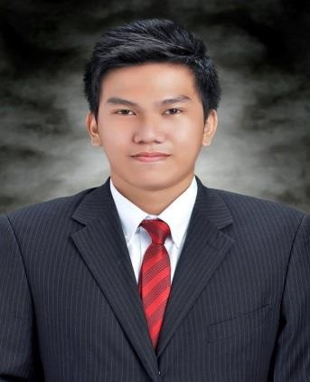

Roi
ROI.356297@2freemail.com

OBJECTIVE:

To acquire skills in the field of my specialization and contribute to the continuous growth of the company.

Personal Information:
Nationality : Filipino
Civil Status : Single
Language Spoken : English and Tagalog
Visa Status : Visit Visa

Educational Background:
Don Bosco Technical College,
Mandaluyong City
Information Technology
2010-2014

Special Skills:
- Knowledgeable in M.S Word, Excel, Power Point Application Software
- Support Microsoft Active Directory using services like DNS, DHCP. Administration
- Experience on VLAN switching layer 2 and layer 3
- Knowledgeable on PC Hardware and Software Installation
- Experience of TCP/IP, WAN protocols

Work Experience:

CERTIFIED CISCO NETWORK ASSOCIATE (CCNA) (February 2015 to February 2018)

Company : St. Luke’s Medical Center (March 01, 2015 to March 01,2017)
St Luke’s Medical center is the foremost and the most admired hospital in the Philippines

Position: System Administrator

Job Descriptions:
- Monitor Java Management Console threshold of Live Threads, CPU Usage, and Memory Utilization of System Application.
- Monitor Oracle Enterprise production database sessions
- Document Analysis and Incident Reports of Outages.
- Email to the corresponding team an AWR Reports, Thread Dump and Screenshot Once Outages encountered

Company : St. Luke’s Medical Center (March 01, 2013 to January 17, 2015)
St Luke’s Medical center is the foremost and the most admired hospital in the Philippines

Position: System Support Administrator

Job Descriptions:
- Administer user’s windows account and password
- Administer account and instructions to users regarding healthcare issues
- Administer Active Directory and user’s credentials
- Monitoring of healthcare issues, internet problem, online printing
- Creating queue ticket for users concern
- Monitoring of Deployment updates from the Healthcare server.
- Monitoring of Healthcare Server down, Slowdown 24/7.
`

