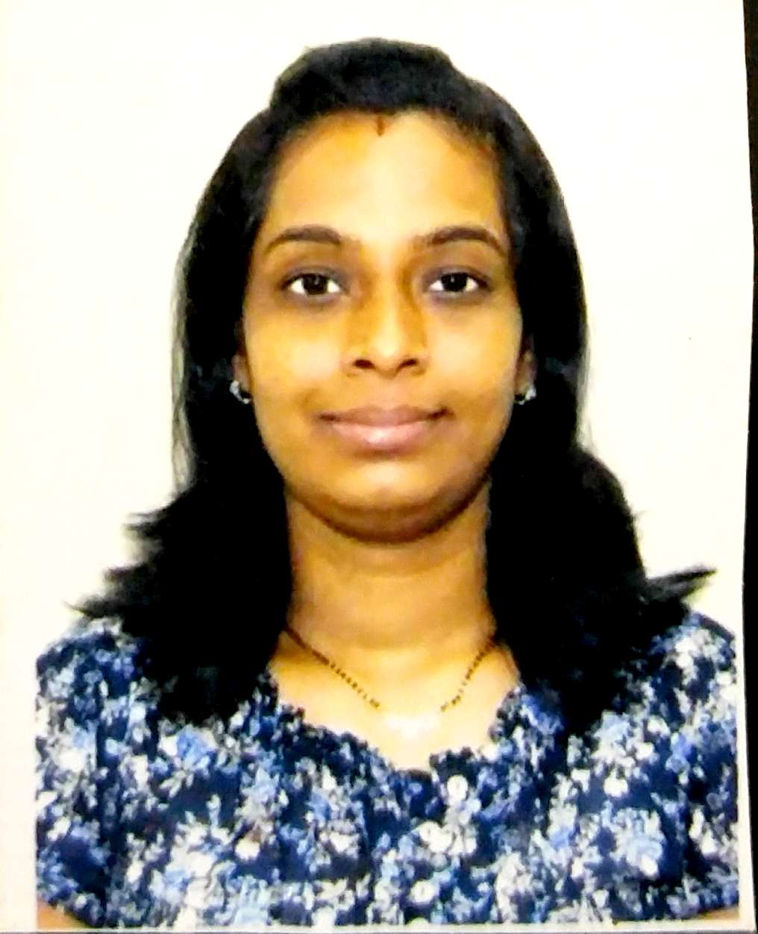 Curriculum Vitae

Personal detail

Name : Dr. Deepa
Deepa.356397@2freemail.com

- Age : 36 yrs

- Gender : Female

- Date of Birth : 04 / 11/1980

- Marital Status : Married,Husband (M.D.Pathology).

- Nationality : Indian

- Languages Known : English, Hindi,Marathi.

Academics:

Degree | Institution | Board/University | Year of passing | Class
SSC | Zilla Parishad Girl’s,High  school,  Umarkhed | Maharashtra  board  Amravati Division | 1996 | First Class
HSC | G.S.G.  College,  Umarkhed | Maharashtra  board  Amravati Division | 1998 | First  class
M.B.B.S. | V.N.G.M.C.  Yavatmal | M.U.H.S. Nashik  University | 2004 | First  class.
M.D.  OBGY | G.G.M.C  Mumbai | Mumbai  University | 2008 | First Class

Clinical Experience :
- I have worked as Assistant Professor at Grant Medical College and Sir J.J. Group of hospitals.
- Worked as Consultant at Sushrut Hospital ,Savda,Jalgaon , Maharashtra.
- Worked. at ESIC Hospital, Andheri(E) as an SENIOR RESIDENT.
- Worked as Junior Consultant at Noble hospital ,Ghatkopar ,Mumbai.
- Worked as Consultant at vertex hospital, Mulund, Mumbai
- Worked as Consultant Gynecologist at Shiddhivinayak Hospital, Thane west ,Maharashtra .
- Presently working as Specialist Gynecologist at Aster Clinics, Abu Hail, Dubai ,UAE .
- Total Work experience of – 8 years & 9 months .
Paper Presentation’s :
1 ) 33 rd Annual conference of MOGS Presented a
Interesting Case entitled OVARIAN ECTOPIC PREGNANCY MANAGED MEDICALLY : A RARE CASE
2) 34 th Annual CONFERANCE OF MOGS presented scientific paper on DIDELPHUS UTERUS WITH PROLAPSE WITH 32 WEEKS FIBROIDNON 19 th March 2006
3) 35 th Annual conference of MOGS Presented scientific paper on INTEGRITY OF SCAR IN PREVIOUS LSCS ON 17 th March ‘07.
Certificate of Participation :
- STAGE DIEBETIC MANAGMENT AND TRAINIG PROGRAMM on 27 th Sept 2008.
- Integral management of neonatal and childhood illness on 15 to 19 th 2008 at GRANT MEDICAL COLLEGE MUMBAI.
- CME on EVOLVING CONCEPTS OF OSTEOPOROSIS held
on 11 th June 2011.
Training Course :
- NO SCALPEL VASECTOMY on 12/01/2009 to 14/01/2009 in NSV
Training Centre Family Welfare Unit F South , Parel, Mumbai.
2) Certification in Ultrasonography by Ian Donald Inter-university School of Medical Ultrasound ,at Dubai ,UAE.

3) Certification and training of Basic Life Support (BLS) for Healthcare professional Provider course at , Dubai ,UAE.

