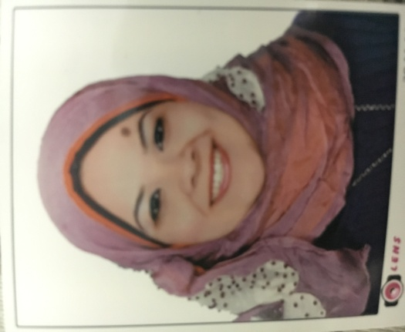
Hend
Hend.356399@2freemail.com

Personal date

Date of Birth | : | 17/2/1987
Personal statement

Seeking to find a work opportunity that matches my qualifications at a reputable educational institution where I can use my strong influencing skills
Education

Bachelor of Arts - Tanta University

Documents and Libraries Department

Graduation year: May 2007

Grade: Good

Holds a Pre-Masters in Documents and Libraries

Work still in process in Master degree under supervision of prof. Mohammed Fathy Abdullhadi.

Courses:

English course, American University (Excellent- Grade A)

ICDL course (Gold Certified – Excellent)

MA chine-Readable Cataloging (MARC21) course from Alexandria Library

Previous Experiences:

Librarian in Al-Geel Al Moslem secondary language school for four years from 2009 to 2013.

Working as a part-time intern at the Central Libraryat tanta university from 15,March,2016 till now.

Skills & features

Language

Arabic: mother tongue.

English: speaking, reading and writing fluently.

Computer usage:

Old handed user of windows operating systems with its different version.

Good user of MS office.
Additional skills

Learning new skills as required.

Enthusiasm to make things happen and achieve goals.

Soft skills: Body language, communication skills and presentation skills.

Business Language

Time management and meeting deadlines in time .

Self motivated and eager to learn more .

Very hard worker under pressure
- Able to work individually and as a co-operative team member.
- Able to penetrate new careers and fields.
- Available Driving license.
Goals & Vision

Welling to find a job which meets my interests where I can be distinguished.

Trying to have a job in which I can promote & make achievements

Dreaming with penetrating and learning new fields and building success to be fluent in my field

Having a good job with a satisfying salary to have a stable life

