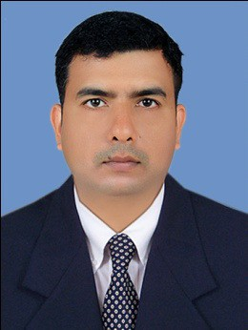
CURRICULUM VITAE

ANEESH
Mob. C.o 971503718643
Aneesh.356406@2freemail.com

OBJECTIVE:

A responsible position in a progressive organization which could provide me with a challenging opportunity for organization as well as my growth and which offers security and professional growth.

WORK ACTIVITES

    - To supply the highest level of customer care and service whether in the public eye or in the back areas.
    - To assist with the acceptance and storage of deliveries and that all-relevant company procedures are adhered to.
    - Responsible for minimizing potential customer relation problems.
    - Always ensures to maintain work area to a clean, hygienic and tidy state at all times.
    - Responsible to provide on the job training to junior members in service department.

PERSONAL SKILL

Planning and coordinating skills, excellent verbal and written communication skills, ability to deal with people diplomatically, willingness to learn.

PROFESSIONAL EXPERIENCE

- GRAND BARBEQUE RESTAURANT (GLOBAL VILLAGE),DUBAI.
Presently working as a Captain

M & M FORKS Restaurant, Sharjah, UAE.
Worked as a Supervisor

Mathan Hotel Banglore (Sterling Mac Hotels pvt. Ltd).
Worked as a Captain

Hotel Horizone Trivandrum.
Worked as a Trainee Captain

Hotel Grand Ashok, Banglore
Worked as a waiter

Hotel Horizone, Trivandrums.
Worked as a waiter

Hotel south Park Trivandrum.
Worked as a Trainee waiter

Hotel south Park Trivandrum.
Vocational Trainee

Academic Qualification:

Pre-Degree
(From Kerala University 1997-1999)

Technical Qualification:

HOTEL MANAGEMENT DIPLOMA IN F& B SERVICE
(From J.G.M. Institute, Kollam (05.01.2000 – 31.12.2000)

Personal Details:

Date of Birth : 12th May 1982 Sex : Male
Religion : Hindu
Nationality : Indian Marital Status : Married Date of expiry : 19/05/2021 Height : 160cm
Weight : 65 Kgs

Languages Known:
English, Hindi, Malayalam & Tamil

Hobbies:
Listening Music & Travel

Declaration
I here by declare that all the above furnished information me is true and best knowledge and belief.

Aneesh Date:

