CURRICULAM VITAE
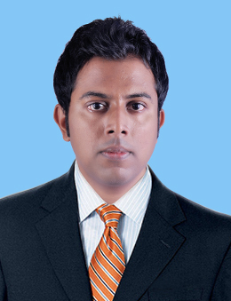
Mohammad
M.B.A –HR & MARKETING
Mohammad.356440@2freemail.com

Career Objective:
Seeking a challenging and responsible career in a growth oriented environment. Intend to give the best out of any given opportunity through steadfastness of purpose, dedication, etiquette and sincerity.

Work Experience:
Company : Hadaf Al Khaleej Debt Collection (TAHSEEL)
Designation: Recovery Officer
Duration : May 2015 –Dec 2016

Key Responsibilities:
- Following on late payments and arranging reminder calls to customers
- Arranging meetings with customer to offer amicable settlements on write off accounts
- Negotiate with bank for good discount on behalf of customers
- Assist customers for settlement letter and clearance letter from bank
- Tracing skip customers and establishing contact in order to collect payments.
Company : MFG Jewellery Product,Mumbai
Designation : HR Assistant
Duration : July 2012 – Oct 2014
Key Responsibilities:.
- Understanding manpower requisition from the concerned department.
- Sourcing candidates that match the desired skills.
- Screaning the candidates by conducting telephonic or personal interviews.
- Ensure planning. monitoring and appraisal of employee work results while design a proper career plan for performing personnel.
- Maintain human resource staff by recruiting, selecting, and training employees.
- Maintaining and updating the database of the candidates.

Tools and Techniques:

- SAP(MATERIAL MANAGEMENT –END USER LEVEL)
- MS Office package

Educational Qualification:

- Master Of Business Administration (M.B.A –HR&MARKETING) Anna University, Tamilnadu, India.
- Bachelor of Science (I.T) Manonmaniam Sundaranar University, Tamilnadu, India.

Personal Skills:
- Comprehensive problem solving abilities.
- Willingness to learn.
- Team facilitator and hard worker.

Personal Information:

Date of Birth : 12.05.1988
Gender : Male
Marital Status : Married
Nationality : Indian

Languages Known:
Speak : English, Tamil &Malayalam
Read : English, Tamil
Write : English, Tamil

Declaration:
I Mohammad, hereby declare that the above mentioned information is correct to the best of my knowledge and I bear the responsibility for the correctness of the particulars.

