Shamil Shamil.356470@2freemail.com
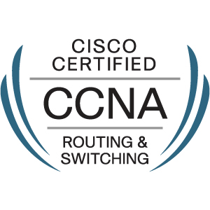

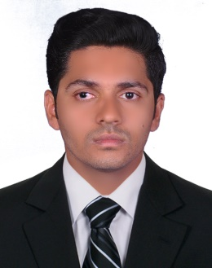

Objective

Interested in a long-term relationship with a reputed firm to share my valuable experience in networking,Windows Server administration and Hardware Maintenance, this remains my passion.
I am optimistic about putting in exceptional performance in any kind of challenging environment as my endeavor in the profession is to excel in the responsibilities entrusted by my organization

Experience
- Sify TechnologiespvtLtd 17th July2014– 9thApril 2016
- Maksat Technologies pvt ltd12th April 2016 – 8th March 2017

Designation:Network Administrator
Responsibilities:
- Monitoringnetwork links&troubleshooting
- Managing LAN& WAN connections
- Maintaining and troubleshooting hardware, printer and Network related issues
- Integrating SifyRf connectivity with BSNL wired VPN or MPLS
- Installations of switches, Routers And Modems in Client Side
- Installing and maintaining Windows servers 2008/2012.
- System Administration-Managing Users, Groups, Roles and Access Permissions
- Installing and configuring DHCP, DNS, NAT, WDS services
- Configuration ofHP MSR 20-20,HP MSR 30-20,CISCO 1800,2800,3600 series Routers
- Configuration ofJuniper EX4200 (24T,48T) Layer 3 and Catalyst 2950,3550 switches
- Installation of wireless Rf devicesat customer side(SMAC,RADWIN,CAMBIUM)
- Installation of wirelessAP deviceson Base Station side(SMAC,RADWIN ,CAMBIUM)
- Configuration of Fortinet40c Router
- Configuration of modems V.35 and E1
- Trouble shooting of Customer issues Through remotely
- Firmware upgradation of routers
- Supporting Field Engineer on remote For configuration issue
- Coordinating & assigning of Engineers to Base Station / Customer site visit required.
- Feasibility studies, checking feasibility of customer location
- Testing of wireless RF signals
- LAN cabling and network migration
- Installation of Operating Systems including Windows 7,8,8.1,10
- Coordination with BSNL For Wired MPLS and VPN

Education
2010 – 2014B-Tech in electronics and communication [CUSAT University]
2007 – 2009 Higher Secondary[Kerala state board]
Additional Qualifications
Courses completed: A+, N+, CCNA, and MCSE
Operating Systems: Windows 2012 Server, Windows XP, Windows 7, Windows 8
Windows 8.1,Windows 10

Professional Certification

Cisco Certified Network Associate(CCNA)
Microsoft Certified Solutions Expert: Server Infrastructure (MCSE)

Professional skills

- Troubleshooting and maintaining of interoffice systems and LAN.
- Installing, configuring and administering Active directory.
- Installing and configuring DHCP, DNS, VPN, NAT, WDS services etc.
- Installing and configuring Hyper-V.
- Installing and maintaining Windows servers 2008/2012.
- Installing and maintaining Windows desktop operating systems.
- Perform data backups, recovery and migration operations.
- Troubleshoot, Diagnose and repair Network related Problems.
- System Administration-Managing Users, Groups, Roles and Access Permissions
- Maintaining and troubleshooting hardware, printer and Network related issues
- Installing and maintaining windows desktop operating systems

- Protocols/Standards: RIP, RIPV2, OSPF,EIGRP,VLAN, ACL, NAT, STP ,RSTP, VTP
- Designing IP addressing scheme using Subnetting.
- Routing(1800,2800,3600,2900,7200) series
- Configuration of HP MSR 20-20, HP MSR 30-20 series Routers
- Router Redistribution
- modem configurations (ADSL, V.35, E1)
- Configuration of Fortinet40c Router
- IOS installation and troubleshooting
- DHCP spoofing on Cisco router
- Switching (2950,3550,3750,3770) series
- Configuration of router redundancy protocol HSRP,VRRP
- Configuration of Ether-channel port aggregation
- Configuration of Inter VLAN Routing
- Setup and configure Telnet to access and configure remote routers & switches
- Access port, trunk port and port security
- Maintain and administration of Routers, Switches and VLAN based network.
- Configuration ofJuniper EX4200 (24T,48T) Layer 3 Switch
Conclusion

I do hereby declare that all the particulars and information furnished
Above are true to the best of my knowledge.

