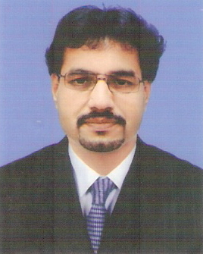
Sridhar
SENIOR PROFESSIONAL: Over 24 years of rich experience in India & Gulf Markets
Business Development, Strategic Planning and Account Management
Outstanding success in driving all phases of sales operations, building new markets, managing operations of large scale dealership and producing sustained revenue growth in the Automobile industry.

Sridhar.356478@2freemail.com

Profile Summary

- Incisive experience in repeatedly producing sustained top-line & bottom line growth and achieving targeted market share through innovative sales & marketing strategies. Impressive success in achievement in consistently meeting assigned sales targets of dealerships & outlets, generating YOY revenue & volume growth and fuelling market-place presence of newly launched Truck and Car Brands.

- Strong exposure in developing distributor & dealer networks across the markets of India and Gulf. Optimized performance levels of channel partners by delivering trainings for dealer staff on product selling; providing support to dealers for resolving customer complaints & improving service score.

- Formulated & implemented marketing, branding and promotional activities; creating & positioning brands and executing creative ATL / BTL activities & visibility campaigns in market to attract customers. Proficiency in building distribution network with financially strong and reliable dealers; planning, & setting sales targets for dealerships and monitoring achievement of same; developing dealer business cases and setting up dealer operating standards & business plan. Enterprising & dynamic leader with well-rounded leadership, planning, analytical and negotiation skills.

- Strong exposure in Vehicle Finance & Vehicle Insurance. Unique and exceptional customer relationship skills along with diversified Sales Experience (Direct, Retail, Corporate and Channel Sales).

Education
Master of Business Administration (Marketing) from Mahatma Gandhi University 2015
Bachelor of Business Administration from Mahatma Gandhi University in 2013
Diploma in Electrical & Electronics Engineering from MIET Polytechnic, Trichy, affiliated to Board of Technical Education Government of Tamil Nadu in 1990

Soft Skills | Area of Excellence
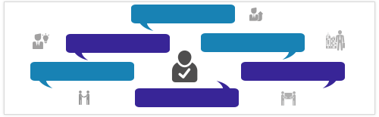  Personal Details  Languages Known: English, Hindi, Arabic, Tamil, Kannada and Malayalam  Motivational Leader  Change Agent Thinker  Collaborator Planner  Communicator  Address: Cirali 705, Goderj Palm Grove, Chembarambakkam, Chennai.  Nationality: Indian  Marital Status: Married  Driving License Details: Driving License: Oman & India, Valid Till 12/06/22  No. of Dependents: 3  Location Preference: South India and Gulf Locations
  Strategic Planning
  Sales & Marketing
  Business Development
  Account Management
  Dealer Management
  Retail & Channel Management
  Branding & Product Promotions
  Strategic Alliances
  Team Building & Leadership
Career Timeline
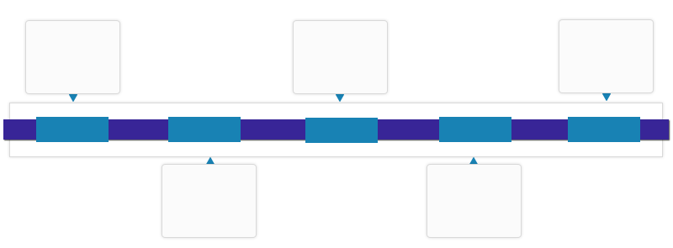
Eureka Forbes Ltd., Team Manager (Coimbatore/ Trichy Division)

Sundaram Honda (TVS Group), Sales Manager- Chennai
Mahindra & Mahindra Ltd., Area Manager (Sales & Marketing)
OTE Group, Branch In-charge (Muscat-Oman)

OTE Group, Senior Manager (Sales & Marketing) - Isuzu Heavy Commercial Vehicles & SUV
1992-1997
1997-2005
2005-2006
2006-2015
Since 2015
- Professional Experience.

Since May’16- Independent Automotive Retail Finance & Insurance Consultant.

Aug’15-Apr’16: Mahindra & Mahindra Ltd., Chennai as Area Manager (Sales & Marketing) - Mahindra Heavy Commercial Vehicles (Mahindra Truck & Bus Division).

Key Result Areas:
- Shouldering the responsibility of managing:
- Mahindra Heavy Commercial Vehicle (25 to 49 ton GVW) as Business Manager for 10 districts in South Tamil Nadu
- Dealers and their business planning & review, business processes, capability, infrastructure, manpower quantity / quality, training & all outcomes for the assigned segments
- Conducting regular dealer visits, leading, mentoring and motivating the team for achieving /exceeding targets by organizing monthly marketing events and customer meets
- Discovering and expanding various HUBs for leveraging market opportunity and penetration
- Organizing daily meet, the Fleet Customers, Financiers and NBFCs for maintaining the rapport and retaining business volumes and new leads respectively

Apr’06 – Jun’15: OTE Group, Muscat, Oman

Growth Path:
Apr’06 - Mar’14: Branch Manager (Muscat-Oman) for Isuzu Light & Heavy Commercial Vehicles.
Apr’14 –June’15: Senior Manager (Sales & Marketing) - Isuzu Heavy Commercial Vehicles & SUV

Key Result Areas:
Senior Manager (Sales & Marketing) - Isuzu Heavy Commercial Vehicles & SUV
- Acted as Business Manager for Isuzu Heavy Commercial Vehicle (16 to 30 ton GVW) and SUV Segments for entire Oman & Government sales
- Entrusted with the task of managing capital & branches, conducting daily branch visits and expanding the branch to leverage market opportunity & penetration
- Collected marketing intelligence about competition & current affairs which impact commercial vehicles & SUV business
- Supervised roll-out of retail finance funding schemes through in-house finance and NBFCs to promote retail sales
- Rendered support to the corporate team to market and promote Isuzu CV as per Government/ Ministry’s CV requirements, submitted quote against their tenders, tracked & closed the deal

Project Detail:
Senior Manager (Sales & Marketing) - Isuzu Heavy Commercial Vehicles & SUV
- Mu-X Test Drive Campaign: Marketing initiative to enhance brand reach to promote the newly launched Isuzu SUV across all branches & Capital region

Branch Manager (Muscat-Oman) for Isuzu Light & Heavy Commercial Vehicles, Pickup & SUV
- Entrusted with the task of promoting the complete range of Isuzu commercial vehicles ( LCV & HCV ranging from 5 ton to 30 ton GVW, Pick Up and SUV) through retail and corporate sales
- Supervised planning and executing regular brand promotional events / customer meets across the territory
- Liaised with the Branch Parts & Service Team to ensure after-sales customer satisfaction

Project Detail:
Branch Manager (Muscat-Oman) for Isuzu Light & Heavy Commercial Vehicles
- Isuzu Truck Festival: Project executed for promoting the Isuzu CV sales through in-house finance and pre owned vehicle division to enhance the resale value of Isuzu vehicles and promote new vehicles sales through old vehicles exchange deals with better and easy finance scheme and approval

Accomplishments:
Senior Manager (Sales & Marketing) - Isuzu Heavy Commercial Vehicles & SUV
- Played a pivotal role in national launching of Isuzu CYZ (18 ton Pay load Chassis) and SUV “mu-X” in Oman
- Successfully promoted “CYZ” through crane and soft drink transport applications and “mu-X” through Corporates and Tunisians segment, which resulted in incremental volume (40%) and market share by 90%

Branch Manager (Muscat-Oman) for Isuzu Commercial Vehicles
- Excellent track record of retailing:
- 17 Isuzu “F Series” HCV in Aug’07 through Fishery Segment (Highest ever HCV sale done by a branch, Approx Business Value 0.6 Million US Dollars)
- 33 Isuzu vehicles in Sep’07 & 35 vehicles in Sep’08 resp. (Highest ever CV retail sale in a month by a branch, Approx Business Value 2 Million US Dollars)
- Attained highest volume growth of 120% in 2008 through customer connect initiatives
- Skillful in developing the branch as a Consistent Performer in Isuzu F Series Heavy duty and NPR 75 (4 ton pay load) Truck segment
- Played a key role in:
- Designing and preparing Isuzu Testimonial Leaflets across all Models and Segments for augmenting market reach and business volumes
- Closing bulk deal of 5 to 10 “F Series” HCVs on several occasions
- Successfully trained many Frontline Sales Executives and developed them as productive sales force for the company

Apr’05 – Mar’06: Sundaram Motors (TVS Group), Chennai as Sales Manager – Honda Cars

Key Result Areas:
- Administered the Honda New Car sales, accessories, trade in car division (auto terrace) and retail finance & insurance department portfolio of the Chennai branch (Honda Cars).
- Supervised planning & executing of different business channels focused on desired customer segment & cost per acquisition
- Managed brand promotions, reaching the customers and generating business by conducting regular promotional activities and strategic alliances (through NBFCs & Auto terrace -trade in car division)
- Ensured sales and services are in line with Company’s & Manufacturer’s CSI policy guidelines

Accomplishments:
- Successfully achieved highest ever in Honda Cars sale, Accessories, Retail Finance & Insurance in Jun’05
- Track record of setting a new record in Honda Car sales consecutively in July, August 2005 and January 2006, resulting in consistently increased sales volumes and market share of Honda Cars in Chennai
- Pioneer in opening-up the new channel sales for Honda Cars through Defence Canteen (CSD) in Sep’05
Previous Experience

Oct’97 – Apr’05: OTE Group, Muscat, Oman as Branch In-charge (Muscat-Oman)
Passenger Cars: Hyundai, General Motors, Subaru and Premium Segment Cars: Cadillac and Hummer)


Jan’92 – Oct’97: Eureka Forbes Ltd., Coimbatore and Trichy Branches as Team Manager

Key Result Areas:
- Recruited, trained, planned and monitored the sales team to achieve the desired sales volume through industrial demonstration methods and procedures
- Discovered new business methods and opportunities to increase the sales volumes

Accomplishments:
- Spearheaded consistent business performing team who qualified for achievers club consistently from 2002 to 2006
- Actively participated in setting-up Coimbatore & Trichy Divisions

