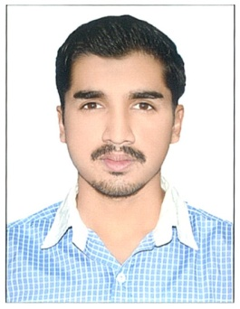

**C**ivil Defence, Ministry Of Interior, Ras Al Khaimah.

March 2012 – Present.

**W**indows server 2008 maintenance, Ministry of Interior network administration, Active directory user management, Local network PHP web program developments, Microsoft access implementation, CCTV camera installation and maintenance, Wi-Fi, lan network installation, Desktop / Laptop software Installation and maintenance, Conference room screen and sound system installation, Department website designs and news updates, Photography, photo/ video editing, Ms Office data entry support for officers, Computer Instruction, Technology Developments, Time attendance Enrollment system maintenance, Department store in charge, 24x7 support, Remote /telephone support

# System Administrator

# WORK EXPERIENCE

# ABDUL

System Administrator

Image result for education icon

**C**omputer Village, Kerala.

April 2009 – September 2009.

# Hardware Service Engineer Trainee

Supporting computer hardware software and networking, Windows98, Server2003, Windows Xp, Vista, Windows 7and other software installation,

# System Administrator

**A**vetech InfoPvt Ltd, Kerala.

January 2010 – January 2011.

**IT** Lab system administration, Online and Telephonic support to clients, Tally licensing, installation, support, Wings, Dashboard, remote accessibility, training new software service trainees.

Teaching Students Photoshop, Corel Draw, Movie maker and basic computer, software marketing, remote desktop sharing and VPN setup,

Related image

**ABOUT ME**

A technology passionate, happy dealing Computer Issues, and finding new ideas to ease work, love learning more and performing more, smart and self managed. Ambition is to be a scientist

**Visa status:** WorkVisa

Sponsor: Ministry of Interior

Related imageImage result for contact logo iphone

**CONTACT ME**

[Abdul.356488@2freemail.com](mailto:Abdul.356488@2freemail.com)

Image result for king crown logo

**MY SKILLS**

* Networking
* Intranet Web Program Developments
* MS Access Implementation
* Web Designing
* Server Maintenance
* Desktop/ Printer Support
* CCTV maintenance
* Conference Room Installation
* Store Keeping
* Data Entry
* Project Leadership
* Tally Licensing

**EDUCATION**

Completed my schooling in Rama Krishna Mission Higher Secondary School, Affiliated to Kerala Syllabus with an aggregate 62 % and 58% respectively in XIIth and Xth standard

Indhira Government Certification in Adobe Photoshop (3 months), (Info-Tech Pvt ,kerala)

**OTHER CERTIFICATIONS**

Diploma in Computer Hardware, Networking and Basic Electronics from Regional Technical Institute (1year), (Pvt Institute,Kerala)