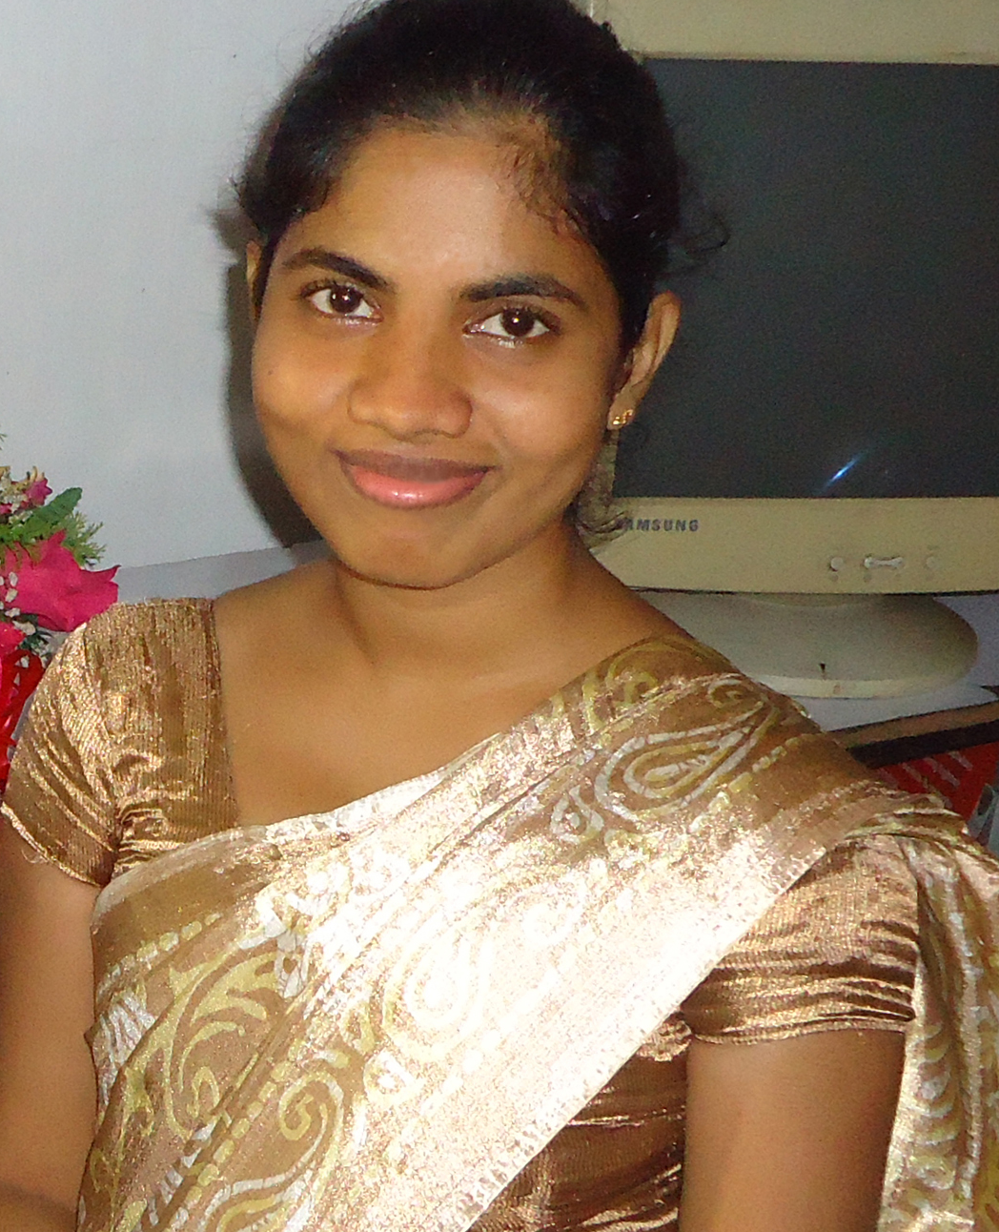 | Dilini.356530@2freemail.com

Personal Information

Sex : Female
Nationality : Sri Lankan
Civil Status : Married
Date of Birth : 30th December 1987
Age : 29 Years

Education

G.C.E. (O/L) Examination

Subject Grade
Mathematics C
Sinhala C
Buddhism C
Social Studies C
Science S
Home Economic S
Art S
History S
Sinhala Literature S
English S
Information & Communication
Technology B

G.C.E. (A/L) Examination

Subject Grade

(A/L) General Information Technology (English Medium) S

Computer Skills

I have followed a Professional Diploma in Graphic Designer conducted by Lalith Athulathmudali Vocational Training Center (National Youth Services Council Ministry of youth Affairs and Skill Development) at Ratmalana in Sri Lanka.

Course Contents:

Collecting Customer requirements & Documenting the Graphic Designs

Designing (Adobe Illustrator, Adobe Photoshop, Adobe InDesign, CorelDraw)

Printing and Finishing

Management (Pass Mark: A)

- I have followed a Diploma in Computer conducted by Star Computer Academy at Kolonnawa in Sri Lanka.
- I have followed a Level 1 Computer course conducted by Star Computer Academy at Kolonnawa in Sri Lanka.
- English Typing ability.

Other Qualifications

Scouting
- Has followed Phase I Scouting/cub leadership course
- Has followed Phase II cub leadership course
- Has followed Phase III cub leadership course
- Has followed Phase IV cub leadership course
- Has followed Phase V cub leadership course

- Wood Badge holder – Higher Certificate of cubs scouting
- Scout Proficiency badge examiner – Energy conservation (Sri lanka sustainable Energy Authority)
- Scout Proficiency badge examiner – Computer Operator Information Techonology
- At Present working as scouting lecturer at Kudabuthgamuwa Sri Rajasingha Central College and Royal Institute, Nugegoda.

Working Experience

- I worked as Computer Operator at Kudabuthgamuwa Sri Rajasighe central College in Sri Lanka since 2014.
- I worked as Computer Teacher at Kalyani Computer School in Sri Lanka since 2007 (Part time)

I hereby certify that the information provided above is true and correct to the best of my Knowledge.

