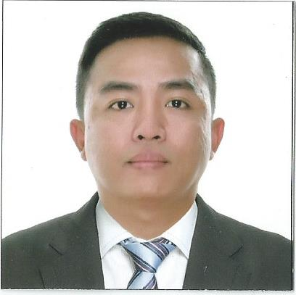
RYAN CHRISTIAN

Dubai United Arab Emirates
Email: ryanchristian.356606@2freemail.com

CAREER OBJECTIVES: To be a productive individual by working in company that will offer me the opportunity to partake in their goals and vision and to join work force that will further enhance my knowledge, skills, and experience through training.
_____________________________________________________________________________
EDUCATIONAL BACKGROUND:

TERTIARY: University of Perpetual Help System Dalta- 2001-2006 (BS Information Technology)

SECONDARY: St. Tomas Montessori School, Sto Tomas Batangas-1996-2000

PRIMARY: Mother Barbara Micarelli School, Sto. Tomas Batangas-1990-1996
______________________________________________________________________________

WORK EXPERIENCE:

COMPANY: Specialized Medical Center Hospital
ADDRESS: Riyadh Saudi Arabia
POSITION: Medical Insurance Coordinator

DURATION: July 2013 – July 2016

Duties and Responsibilities:

- Assists patients with the processing of medical insurance
- Sending medical services of the patient into their respective insurance company
- Closing medical services of the patient into our system
- Reviewing medical records and x-ray and preparing these records for archiving following Medical Records Archiving Policies and Procedure
- May assist with other data entry and administrative duties as required
- Analyze and correct billing reports
- Prepare necessary UCAF to send and obtain approval in each credit patients with their respective insurance company
- Prepare and checking daily routine census for Out-Patient
- Follow-up approval of each patient in hospital
- Seek out medical report to attending physician in each insured patient
- Communicate and do follow-ups with all insurance companies regarding coverage status of the patient (e.g. approvals, pending, rejection , antiselection cases, and referrals )
COMPANY: Spi Global
POSITION: IT Staff/ Data Technician
DURATION: March 2011 - September 2011

Duties and Responsibilities:

- Responsible for performing data review and conversion and/or editing based on project requirements and specifications.
- Converts or edits files to SGML format.
- Proofreads the documents and if permissible (based on project) makes necessary edits.
- Receives and reviews source documents through the CID (Check-in-Document) process. Checks for completeness and legibility.
- Works with co-Data Technicians for the quality inspection.
- Publishes or moves up the file online once approved during the peer review.
- With typing skills of 100% accuracy and 56wpm
- Proficient in the following: HTML, Explorer and/or Salamander, MS Word, MS Excel, and MS Notepad

COMPANY: Zenzou Roofing System
POSITION: Office Clerk
DURATION: January 2007 - Jan 2011

Duties and Responsibilities:
- Encodes specific Data
- Inventory of Roofs and supplies
- Greet public and clients and direct them to the correct staff member
- Receive, sort and distribute incoming mail
- Monitor incoming emails and answer or forward as required
- Maintain office filing and storage systems
- Update and maintain databases such as mailing lists, contact lists and client information
- Type documents, reports and correspondence
- Co-ordinate and organize appointments and meetings
- Monitor and maintain office supplies
- Ensure office equipment is properly maintained and serviced

Skills
- Computer Literate
- Knowledge in trouble shooting
- Knowledge in Networking ( LAN)
- Knowledge in Microsoft Office
- Able to type 60-70 words per minute with 99% accuracy
- Knowledge on computer hardware and software
- Has good communication skill
- Precise and accurate in following directions and orders
- Able to work harmoniously and effectively with others

Seminars Attended:
Training Course “MEDICAL TERMINOLOGY”
Specialized Medical Center Hospital

PHILIPPINE YOUTH CONGRESS IN INFORMATION TECHNOLOGY (Y4IT)
University of the Philippines Diliman
September 2-3, 2004

Organization:
JPCS Member
2004 – Present

ON-THE-JOB TRAINING:
PT&T
Real, Calamba, Laguna
August 2003 – November 2003

DTI-V A
Real, Calamba, Laguna
February 2004 – March 2004

DEPARTMENT OF LABOR AND EMPLOYMENT (DOLE)
Calamba, Region IV CALABARZON
July 2004 – November 2004

