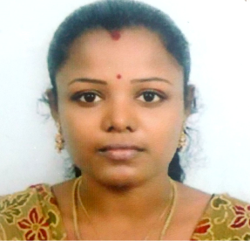

KAVIARASI
KAVIARASI.356627@2freemail.com

Objective
Seek a position as Mathematics Teacher where I can groom up the young generation with my knowledge and ability.

Professional Experience
- 1 Yr of experience in Little Angels Matriculation Hr.Sec.School, Chennai.
- 2 Yrs of experience in Velankanni Matriculation.Hr.Sec.School, Chennai.
- 1 Yr of experience in Indian Polytechnic College, Vadakankullam.

Responsibilities
- Handled classes from 9th to 12th with Mathematics as main subject in Little angels.
- Handled Mathematics for students from 6th to 9th.
- Interacting with students and solve their problems.
- Arranging meetings with parents and discussing the development of children.
- Organizing students in group to interact with each other and socialize.

Education
- Graduated M.Sc. with 64% from Vivekananda College (Apr-2007).
- Bachelor of Education (B.Ed.) with 63% from M.E.T College of Education(Apr-2008)
- Bachelor degree (B.Sc.) with 82% from Vivekananda College (Apr2005).
- Higher Secondary with 77% from St.Annes.Hr.Sec.School(Apr 2002).
- SSLC with 87% from Govt.High .School.(Apr 2000).

Skills and Competencies
- Ability to teach the lessons in an interesting manner so that the students see the logic and retain the information.
- Participative style of teaching.
- Well versed with virtual teaching platforms.

Personal Details

Personal Data:

DOB : 10.02.1984

Gender : Female

Nationality : Indian

Marital : Married

Current Location: Sharjah, UAE

Status of visa :Husband visa

Linguistic Abilities:

Tamil & English

Personal Strengths:

Self-confidence, Team Player, Human relationship and easy going with students.

Hobbies:

Surfing net, Listening songs, Cooking, Playing with kids.

.

