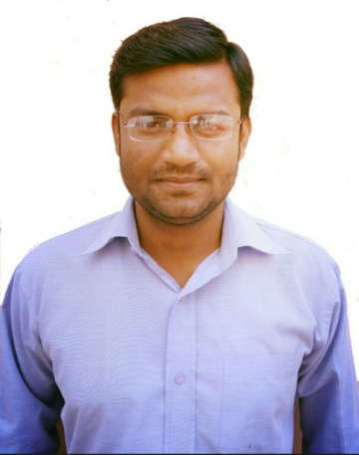
TANVEER

Mobile: C/o 0502360357
e-mail: tanveer.356705@2freemail.com

ACADEMIC QUALIFICATION

- Bachelor of Commercefrom ChhatrapatiShahuJi Maharaj University, Kanpur

WORK EXPERIENCE

- One year in Basic Education Department as acomputer operator
- Provide necessary changes in computer operating systems and accumulating the records
- Supply various features of data entry and documentation
- Responsible for collecting data and implement operating system upgrades

- One year in State Council of Educational Research and Training as a computer operator
- Worked as an assistant to the office manager in-charge
- Provided vital role playing in the operating of the system
- Responsible for unloading and separating output of printer in preparation for distribution

- One year in Cyber Cafe, The Internet Shop
- Assist customers when they have trouble or questions using computer software such as Microsoft office, Adobe software and all software that are being used in the cyber cafe.
- Provide services such as printing, downloading and all other operations provided by the cafe.
- Troubleshoots different kinds of computer programs, hardware and software.

OFFICE SUPPORTED SKILLS

- Microsoft Word, Microsoft Excel, Microsoft PowerPoint
- Knowledge of computer maintenance and software installation
- Able to understand the problem with program or computer
- English and Hindi Typing
- Multi line telephone controlling
- Documentation and filing
- Knowledge of handling quality photocopy machines and the fax machines
- Designing the front page of different types of projects
- Done duties such as implementation, documentation of LAN/ WAN network system

EXTRACURRICULAR ACTIVITIES

- Certification Course inOne Year Advance Computer Software
- Certification Course inNCC (National Cadet Corps)
- Certification Course inNSS (National Service Scheme)

PERSONAL STRENGTH

- Ability to deal with multiple tasks
- Ability to remain focused and to perform under pressure
- Highly analytical thinking and ability to grasp concepts quickly
- Ability to relate to people across all levels of an organization
- Ability to form strong working relationships and develop a rapport with Managers, peers, and external contacts alike

PERSONAL DETAILS

Date of Birth :12th Jan, 1992
Sex : Male
Marital Status :Unmarried
Nationality : Indian
Linguistic Proficiency : English, Hindi
Hobbies : Listening to music, Surfing Internet.
Strength : Hard working, Innovative, Honest.

DECLARATION

I do hereby declare that the information provided above is true and correct as per my knowledge.

Date:

Place: (Tanveer)

