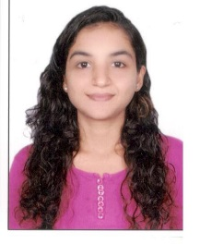
Dr. Kajal
Kajal.356840@2freemail.com
DHA Eligible

Objective
Enthusiastic, career-oriented and talented dental professional with sound knowledge of dental care processes and procedures. Looking forward to taking up the responsibilities of a General Dentist with a reputed medical facility in Dubai
Professional strengths:
- Possess 3+ years of professional experience as a General Dentist
- Extensive knowledge of medical tools and equipment used in dental treatments
- In-depth knowledge of examining x-rays, teeth straightening and filling cavities
- Ability to perform dental surgical procedures like replacing missing teeth
- In-depth knowledge of various preventive measures on teeth related diseases
- Ability to provide effective oral hygiene techniques
- Ability to perform dental surgeries effectively and efficiently
- Excellent command over written and verbal communication and presentation skills
Experience
Shreeji Dental Clinic – General Dentist: 2013 – 2016

- Examining Patients and interpreting radiographs and diagnostic tests to determine the type and extent of dental diseases, disabilities or dysfunctions
- Restoring the form and function of carious, fractured or otherwise defective tooth
- Teeth cleaning, whitening and polishing
- Root Canal Procedures – Single Sitting, Multiple Sitting, post and core build ups
- Tooth extraction – Non surgical extraction, surgical extraction, placing and removing sutures
- Tooth preparation to receive crowns and bridges
- Artificial dentures to replace missing teeth
- Assisting Senior Dentist in Dental Implant procedures
- Treating paediatric patients with dental complaints
- Purchase of dental material and equipment
Education Qualifications
- B.D.S: Pravara Institute of Medical Sciences (2007 – 2012)
- Dental Internship: Pravara Institute of Medical Sciences (2012 – 2013)
- DHA Exam: 2017

