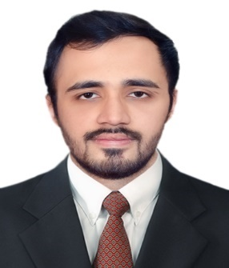
Muneeb

email: muneeb.356850@2freemail.com

Profile:
A dedicated team player with sound communication and management skills, extensive knowledgeof ElectricalEngineering concepts and creative aptitude.

Education:
Bachelor of Science: Electrical Engineering, (Feb,2017)
University of Engineering & Technology – Peshawar
CGPA: 3.16

HSSC: Pre-Engineering, 2012
Islamia College Peshawar
84% marks

SSC: Matric, 2010
Peshawar Model School
86% marks

Achievement:
Represented Pakistan as a Cultural Exchange student at University of Southern Indiana, USA for a semester (Fall 2015) under Global Undergraduate Exchange Program for Pakistan.

Experience:
Intern
July 2016 to August 2016
Pakistan Television Network (PTV) – Peshawar, KP

Intern
June 2015 to August 2015
PESCO – Peshawar, KP

Teaching Assistant of Basic Electrical Engineering and Engineering Economics
September 2013 to June 2014
UET, Peshawar

Key skills:
- MS Office (Word, Excel, Power Point)
- MATLAB, PSpice
- Computer Programming (C++)
- Electrical Drafting
- Network Simulator (ns-2)

Academic Projects:
Wireless Power Transmission (Senior Year Project):
The aim of this project is to study and design an efficient mechanism through which power can be transferred wirelessly. Basic principle of wireless transmission used here is of Electromagnetic induction. The final product for this project is a handy charging pad, which is able to charge cell phone on it without any wired connection.

Semester Projects:
Water Level Indicator (89C51 Microcontroller)
Single Door Customer Counter (89C51 Microcontroller)

Extra-Curricular Activities:
- Arranged various IEEE events i-e Space Week, FYP Guide etc. on campus, UET Peshawar, 2012-16.
- Completed 20 hours of community service, and country presentation about Pakistan at University of Southern Indiana, USA, Fall 2015.
- Workshop on Responsible Leadership, California State University, Monterey Bay, November 15-18, 2015
- Two Day Seminar on Electrical Tariff by USAID, UET, Peshawar, December 21-22, 2016

Memberships:
- Institute of Electrical and Electronics (IEEE), Local Chapter Member
- Society of Automotive Engineers (SAE), Local Chapter Member
- Rotaract Club, UET Peshawar
- Being Human, UET Peshawar

