CURRICULUM VITAE (C.V)
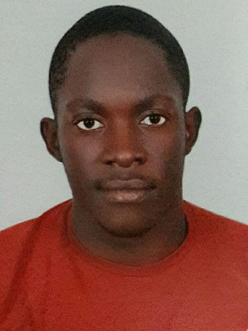
Kendrick
Kampala, Uganda
Tel: C/o 0502360357
Email: Kendrick.356903@2freemail.com
Date of Birth: 24/12/1992
Marital Status: Single
Nationality: Ugandan
Visa status: Visit visa

PROFILE
I am highly creative, self-driven and result oriented. Besides I am a team player with excellent leadership traits, organizational, analytical and decision making skills. I am proficient in oral and written communication, able to work under pressure, committed to change and fostering innovation and able to work under pressure

EDUCATIONAL BACKGROUND
YEAR | INSTITUTE/SCHOOL | AWARD
2014 - 2016 | Uganda Martyrs University of Science | Diploma in Computer Science and Information Technology
2013 - 2015 | Makerere University of Science | Bachelors in Telecommunication  Engineering
2013 - 2013 | Optical Fiber Solution | Certificate of Completion of Fibre Optic Training
2011 – 2012 | St Lawrence SSS Ssonde Namugongo | Uganda Advanced Certificate of Education (UACE)
2007 – 2010 | St Lawrence SSS Ssonde Namugongo | Uganda Certificate of Education (UCE)
2000 – 2006 | Nakasero Primary School | Primary Leaving Examination (PLE)

WORK EXPERIENCE
March 3rd 2013- March 20th 2014
Duty: Assistant Telecom Engineer /Mbarara deputy regional manager
- Worked as an Engineer for telecom companies MTN, Airtel, Roke and Liquid Telecom network across Uganda

- May 1st 2014 – march 15th 2017
Duty: Telecom Engineer /Masaka regional manager

- Started working for Bandwidth and cloud services in Uganda under Techgeeks Uganda on Airtel and BCS network
- Trained other fiber technicians that have proved to be useful in the different companies they have been employed in.
- Worked with my team to ensure good uptime of our network throughout the region
- Data analysis most especially in Microsoft office packages like (MS Word, Excel, and MS power point)
- Connected new clients throughout the region in various network types such as use of WIMAX, ADSL, NANO BEAMS, AIRMUX
- Configured cisco routers, switches

KEY COMPETENCE AREAS:
- Knowledge with the use of OTDR, Splicing machine, power meters, multimeters, fault detectors
Light detectors

- I am a skilled Telecom engineer experienced in optic fiber networks and equipment Data leased lines (Alcatel main street and RAD), ADSL, WIMAX, Airmux RAD/Airmux Nano bridge, Gsm Mobile/Fixed, CDMA, SDH and PDH Radio transmission systems, E1 transmission, Landline OCB/NGN and ISP networks,SDH, 4G and 3G Technologies, CISCO Routing and switching and Electrical power systems at Uganda Telecom Masaka and have knowledge with IP switching

- I have been consistent in the past two years performing hands on installations, maintenance, quality, faulty/ troubleshooting, equipment repairing, system backups at UTL masaka Telephone exchange.

- I have a strong background in all fixed technologies, data networks and great skill in hardware support for IT equipment, CISCO systems, good practical knowledge in copper and fiber laying, installation, fault troubleshooting. Good hands on skills in most operating systems and knowledge in computer application.

- Customer wise, I am and have been in direct interface with the wireless network customers regarding new acquisitions with customer surveys and service provision, maintenance and development of existing customers, fault clearance, retention of existing customers, quality of service provision, customer follow up regarding needs and complex faults, feedback to appropriate functions.

- All in all, I have been managing the SME business portfolio for Uganda as far my current region is concerned.

- Installing, maintaining and troubleshooting backbone Tejas Network, SDH, PDH radio communication equipment and system.

- Installing, maintaining optic fiber network system and equipment, Installing, maintaining and troubleshooting the Base Station Receivers (BTSs) for GSMS mobile, WiMAX, 3G&4G, maintaining the power system, generators, rectifiers, solar systems and battery banks, maintaining good air conditioning system.

- Software and hardware repair of the Switching Modules and performing routine system backups

- Responding and resolving all customers’ complaints (TTs) as fast as possible especially corporate and enterprise clients including Banks, NGOs, Government bodies etc.

- Performing a routine Maintenance to identify degraded equipment.

- Identifying areas requiring Network upgrade and where possible implement the upgrades while identifying customer needs and providing solutions.

- Windows Server Management.

- Very good working knowledge with all Microsoft Office applications.

- Electrical and Telecommunications Engineering skills.

- Power systems, rectification and generators.

- CISCO systems switching and Routing.

- Optic fiber networks.

- WiMAX and Airmux Data and Internet systems.

- ADSL/DSLAM installation.

- Hardware and software upgrading.
SKILLS AND ABILITIES
- Driving; hold a valid and clean driving permit, able to drive manual and automatic transmitted cars.

HOBBIES
- Driving
- Swimming, volleyball and Basketball
- Traveling to new places
- Reading books and watching movies
- Learning new thing

LANGUAGE
- English Very fluent in speaking and writing

