CHASITH
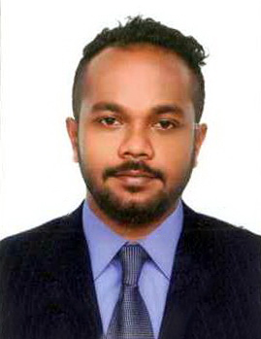
C/o 0503718643
chasith.357030@2freemail.com
OBJECTIVES

- Work together with the purpose of enhancing the image of the company/Organization.
- Be a person who adds great VALUE to the society.
EDUCATIONAL QULIFICATIONS
- Foundation Course in Human Resource Management at Institute of Personnel Management (IPM) of Sri Lanka.
- Diploma in Computer Studies Course conducted by Golden Key Institute.
- Certificate Course in Human Resources Management at Institute of Personnel Management (IPM) of Sri Lanka.
- G.C.E. (A/L) Examination with 2 S's in Maths Stream
- G.C.E. (O/L) Examination with 7 A's and 2 B's including English, Mathematics and Science.
EXTRA CURRICULUM ACTIVITIES

- Member of Western Cadet Band in School.
- Member of Buddhist Association in School.
- Member of Sinhala Literature Society.
- Have participated in Inter House Sports Championship competition.

WORKING EXPERIENCE - DUBAI
- Working as Warehouse Supervisor in Mohebi Logistics in Jabel Ali Freezone. (Loreal Department) since 30th August 2016.
Duties Handling – 1) Handling total returns process
2) Assisting in In-bound and Outbound processes.
3) Working in Warehouse Management Systems (WMS).

- Worked as Warehouse Data Entry operator and Warehouse Transport In-charge at Lifestyle concept in Landmark group from 15th May 2015 to 16th June 2016.
Duties Handled – 1) Reports related to Outbound and Transport
2) Daily delivery Schedule to the stores
3) Vehicle Maintenance
4) Worked in Warehouse Management Systems (WMS)

WORKING EXPERIENCE – SRI LANKA
- Employed as a HR Assistant at LOLC Group (Lanka Orix Leasing Company) from 1st Oct 2009 to 15th Feb 2011.
- Employed as a HR Assistant at HNB Assurance PLC as a HR Assistant from 6th June 2011 to 14th Oct 2014.
Duties Handled – HRIS / Leave & Attendance / Staff loans / Resignation Process

Name : Chasith
PERSONAL PROFILE
Nationality : Sri Lankan
N.I.C. No. : 881590301V
Date of Birth : 07th June 1988
Gender : Male
Religion : Buddhist
Civil Status : Single
Schools Attended : St. Aloysius College, Galle. (1994 – 2004)
D. S. Senanayake College, Colombo 07. (2005 – 2007)

I do hereby declare that the above particulars furnished by me are true and accurate to the best of my knowledge.

Chasith
.....................................................
Signature

