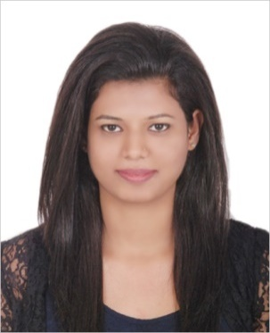
RESUME

Dr. LAYA
LAYA.357032@2freemail.com

Objective
Experienced working dentist seeking for position of general practice dentist in a reputed clinic or hospital where I can use all my knowledge and experience in a better way to benefit the organization

Professional Licenses
>Licensed Dentist in United Arab Emirates (Dubai Health Authority)
>Licensed Dentist in India (Kerala Dental Council - Registration number -12396)
Core Qualification
- Possess 2 years of experience as general dentist from various clinics.
- 1 year of compulsory rotational internship from JKK Nattraja dental college and hospital.
- In depth knowledge of dental hygiene, dental emergencies and techniques.
- Exceptional knowledge of providing patient care for assigned patients under the direct supervision.
- Excellent knowledge of oral health and various dental treatment options.
- Profound ability in assessing treatment planning option with patients.
- Ability to keep abreast of new developments in dentistry.
- Evaluate those patients needing and applying for dental care.
- Excellent ability to work with children and adult patients.
- Familiar with Microsoft word, Excel and the internet.
- Secured top position in the college for the subject of oral pathology and oral microbiology in the year 2011

Professional skills
- Removable orthodontics : Hawley’s appliance
- Removable Complete denture
- Removable partial dentures
- Fixed partial bridges
- Amalgam restorations
- Glass ionomer restorations
- Composite restorations
- Root canal treatment
- Oral prophylaxis
- Oral surgery- simple extractions

Academic qualification
Graduation : Bachelor of dental surgery (BDS) from Jkk Nattraja dental
College (2008 – 2013) under MGR University Chennai, Tamil nadu

Professional Trainings
>Have attended government hospital postings in Bhavani and Erode.
>Participated in seminars and workshops conducted in college.
>1 Year (2012-2013) of compulsory rotatory internship from JKK Nattaraja dental
College and hospital which is a college with 25 years of service.

Career Experience Profile

GRAND DENTAL CARE 5TH NOV 2013 -12TH JULY 2014
General Dentist Cheranellore, Kochi, Kerala, India
- Assigned the task of providing preventive & suitable treatment for mouth and teeth problems.
- Educated patient regarding teeth & mouth care.

VASAN DENTAL CARE 29TH SEP 2014 – 4TH Feb 2016
General Dentist Panampilly nagar, Kochi, Kerala, India
- Handled the task of primary consultant- BDS and OP driver.
- Handled the responsibility of assisting senior dentist in performing dental implant procedure.
- Participated in dental care education, awareness programs and dental camps.
- Handled the task of maintaining and evaluating records of patients.
PEARL DENTAL CLINIC 12TH FEB2016 -15THAUG 2016
General Dentist Poothotta, Kochi, Kerala, India
- Performed task under instructions of senior dentist.
- Coordinated daily activities of dental and support staff.
- Diagnosed and recommended treatment for variety of oral diseases and oral hygiene problems.

Duties and Responsibilities

- Maintained and provided quality care to all patients
- Facilitated to educate patients on oral health and various treatment options
- Assessed treatment planning options with patient
- Carried out agreed clinical treatments
- Campaigned regard new developments in dentistry

Personal Details

- Date of birth - 12/02/1990
- Gender - Female
- Nationality - Indian
- Languages spoken - English, Malayalam, Tamil
- Date & place of Issue - 2-03-2016 and Cochin
- Date of Expiry - 01-03-2026
- Visa status - Visit Visa

“I hereby declare that the above information’s are true to best of my knowledge”

