Judith.357048@2freemail.com

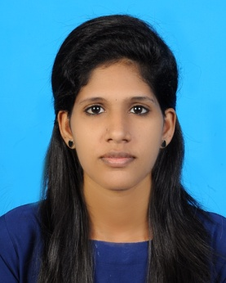
Judith | RESUME  OBJECTIVES  Seeking a suitable position looking for substantial responsibility where my skills and varied experience would be fully utilized in a career opportunity and where and making a significant contribution to the success of my employee will gain me career advancement opportunity.  PROFESSIONAL QUALIFICATION  Diploma in Air line and Airport Management course at International Educational Council Eranakulam (2011)  ACADEMIC QUALIFICATION  - S.S.L.C (Kerala state board)  St Joseph’s H.S., Sakthikulangara, Kollam (2008)  - H.S.E ( Kerala state board)  The Chapter College, Kollam (2010)  - Graduated in BBA(Bharatiar university)

WORK EXPERIENCE
- Worked as Banquet Staff in Hotel Gokulam Park, Kaloor in Cochin for 10 months.
- Worked as Customer Care Executive in First Source Solution Pvt. Ltd. for 16 months.
- Worked as Academic Counsellor cum Front Office Executive in an Aviation Institute

KEY SKILLS
- Capacity of working long hours when its require
- Hardworking
- Yield profit through waste and time management
- Initiative

RESPONSIBILITIES
- To report on time for duty
- Be aware of opening/closing procedure.
- Check the cleanliness of the outlet.
- Maintain the service standards.
- Ensure smooth service by practicing team work.
- Customer satisfaction
- Ensure that complete handover is given at the end of every shift

PERSONAL DETAILS

Name : Judith
Date of Birth : 19/04/1993
Gender : Female
Nationality : Indian
Current Location : Sharjah
Visa Status : visit
Religion : Christian
Martial status :Single
Languages known : English , Malayalam ,

DECLARATION

Ihereby declare that all the above furnished details are true and best to my knowledge and belief

