Eltahir
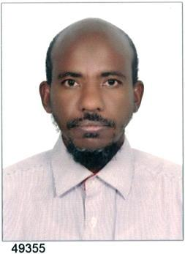
Eltahir.357063@2freemail.com

Cv

*personal information

-Name: Eltahir

-gender: male

-Nationality: Sudanese

-Place &date of birth: Sudan -White Nile state april23rd 1973

-Religion: Muslim

-Marital status: married with one child

-

*Education and Qualification:

-B.M.M.S FROM Omdurman Islamic University-Faculty of medicine - Sudan Nov 13th 2002

- Sudan medical council license November 13th 2007

- Passed GP HAAD exam Uae in Dec 12th 2013

*Experiences:

-Internships shift in Kosti teaching hospital from May 2003 to September 6th 2004.

- Work as Medical officer as follows- . Kosti teaching hospital September 14th 2004 to November

29th 2007,

,.Alaman hospital in Kosti city from November2007 till up to date.

*summary of experiences and training:

*In the second career, Alaman Hospital Dec 2007 to 2017

- Work in emergency &outpatient ,ward ,and deal with such cases in general surgery &orthopedic ,internal medicine, pediatrics, obse&gynecology.

- Well trained to do many major operations in both general surgery ,obe&gyne.

-Do most intermediate and minor surgical operations and such procedures like chest tube, tracheostomy, lumber puncture, femoral samples,

-Very skill in life saving medical procedures such as makes intubation and secures a patent airway, IV line, etc.

-Follow up of patient in wards and inpatients

- work in traumatology and orthopedics emergency and cold cases.

-Make emergency triage, classify patient with abdominal pain surgical from medical and deal with each.

-Present first aid to patients with MI, and treat Asthma, DKA, emergency hypertension, convulsions in pediatrics and adult, etc.

-Make resuscitation and deal with shocked patients according to the target cause.

-Work in anesthesia and ICU

-See the cold cases, chronic diseases, and prescribe drugs, offer advices to them.

*In the first career, Kosti teaching hospital September 14th 2004 to November 29th 2007

- Obse -cover the out patients, labor room (approved by the consultant to do all the emergency, elective operations, and to work as first assistant to the consultant in the theater,. Others).

- Pediatric(cover the outpatient , wards and the neonatology unit ,do procedures like spinal tap, cut down ,…others)

- General surgery and orthopedic, ENT and ophthalma.firstly, approved by the consultant to do all the emergency operations concerns the general surgery, work as first assistant to the consultant in the theater, others .secondly, write the reports for discharging patients and follow up them with the surgeon in the refer clinic. Thirdly, attend the clinical meeting and teaching round, tutorials. Fourthly, cover the out patients and.

- Medicine and psychiatry, derma(cover the outpatient and wards).Follow up of chronic diseases, Offer advices to them, write their drugs and refer them to physician when it needed. etc.

*Skills:

- Computer (MS Office+internet+PowerPoint+exel)

- Language (Arabic&English) speaking, reading, writing

