Curriculum Vitae

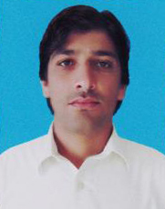
Adil

Adil.357098@2freemail.com

OBJECTIVE
To seek a career position in a progressive organization which should be challenging and demanding where I can practice my repertoire and learnt new skills.

ACADEMICQUALIFICATION

EXAM | YEAR | Marks | Board / University
S.S.C | 2011 | 616/1050 | B.I.S.E Bannu
F.S.C | 2013 | 590/1100 | B.I.S.E Bannu
D.A.E (Civil) | 2014 | 2318/3350 | B.T.E Peshawar
B.S.c | 2015 | 225/550 | Ust Bannu

PROFESSIONAL QUALIFICATION:

IOSH Managing Health & safety Course (IOSH UK)

COMPUTER SKILLS
1: 6 Months Diploma computer office program Typing & Inpage
WORKING EXPERIENCE:
1: 5 Year Experience in Managing Health & safety (IOSH UK)
2: 2 Year Experience in Computer.

LANGUAGES:

- English, Urdu, Pashto

