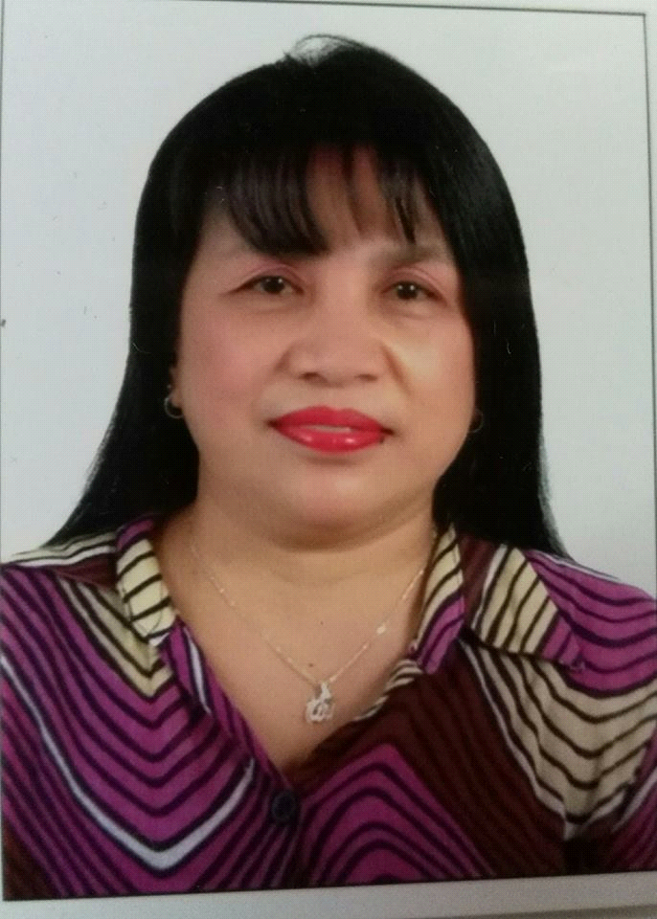 FEBE
FEBE.357119@2freemail.com

POSITION APPLIED: RECEPTIONIST/ OFFICE ASSISTANCE /SALES
CAREER OBJECTIVE
- Reliable worker with the ability to learn new concepts and skills quickly.
- Enhance my adeptness in different areas of job related task.
- Looking for opportunities where I am placed offer my best skills.
- Performance where by career growth.
- Action that would contribute to the Company Success.

QUALIFICATION
- Able and willing to assist coworkers, supervisors and clients in a cooperative manner.
- Committed to providing total quality work
- Dependable employee with common sense and a variety of skills
- Work well under pressure to meet deadlines
- Can work under minimal supervision and always seeks continuous career improvement. An effective team
player but can work alone also.
- Organized, Flexible, Honest, Hardworking, Adaptable, keep on details.

- Friendly and Cheerful, well presented person with clear speech and excellent telephone etiquette. can work
under pressure.
- Fluent in English and Basic Arabic.
SKILLS

- . Telephone & Front Desk Reception

- . Customer Service Filing

- . Data Base & Record Management

- . Executive & Administrative Support

- . Report & Spread Sheet

- Computer Literate in Microsoft such as Word and Excel

WORK EXPERIENCE:

ARMED FORCES OFFICERS CLUB& HOTEL
P.O. Box: 6382, Abu Dhabi – U.A.E
GYM RECEPTIONIST at ETIHAD AIRWAYS
2012 to present

I work from this company until now with good record and performance as well positive and solemnly nice communication from their client & guest, with respect and good moral character. How to handle some cases and make customer feel comfortable, and have a control in anger and being approachable with them.
In addition to this I adapt some knowledge and skills. And for being initiative and understanding in all cases that we encounter everyday at work.

DUTY AND RESPONSIBILITY

- Assist the customer with the smile and respect
- Providing good service to customer
- Provide service with smile to guest/customer a good impression
- To create a good image for the company.

AL AMER TRADING BEAUTY AND SALOON SUPPLY
Hamdan Center, Abu Dhabi – UAE
SALES REPRESENTATIVE
2007 to 2012
DUTY AND RESPONSIBILITY

- .Completed financial transaction, sale and returns.
- .Developed Competence for high responsibility such as product/price verification.
- Cashier

8 YEARS HOUSEMAID:

. Gulf country

EDUCATION ATTAINMENT:

College : University of Mindanao
Course : Bachelor of Science in Commerce
Major in Management
Year : 1980 – 1983 (Undergraduate)

Secondary : University of Southerm Mindanao
Address : Kabacan Nort Cotabato
Year : 1976-1980

PERSONAL INFORMATION:

Nationality : Filipino
Status Single
Visa Status : Transferrable
Religion : Islam(converted)
Language : English,Arabic,Tagalog,Visaya
Current Location : Abu Dhabi

I hereby sign that all the details and information written herein are true and correct.

