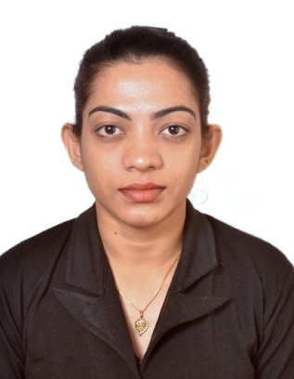
Francisca
Francisca.357135@2freemail.com

- IT Professional having 3.7 years of experience as software engineer and 1.5 years of experience as a computer teacher.
- Seeking assignments in testing or support project across any technology.

TECHNICAL SKILLS

Software Proficiency:
- Basic Knowledge : MS Office Word, MS Office Excel, MS
Office PowerPoint, MS Office Access
- Languages : C , C++ , Java , Visual Basic
- DBMS Packages : MS SQL 2000
- Operating Systems : MS DOS , Windows 2000/XP/Vista
- Web Designing : HTML, XML, PHP
- Diploma in Software Testing (Manual & Automation) course in SEED INFOTECH, Pune.
Hardware Knowledge:
Installation and Updation of Software, Computer antivirus, knowledge about CPU, Mother Board and RAM.

PROFESSIONAL EXPERIENCE

Don Bosco High School, Tuem, Pernem, Goa 4th Jan 2016 – 30th April 2016
- Worked as a Computer Teacher

SFX High School, Siolim, Bardez, Goa 6th July 2015 – 2nd Jan 2016
- Worked as a Computer Teacher

SFX Higher Secondary, Siolim, Bardez, Goa 7th Nov 2014 – 29th April 2015
- Worked as a Computer Teacher

SPRY Resources India Pvt Ltd 17th Sept 2010 – 30th April 2014
Associate Software Engineer

Project: | e-Governance project and e-Governance Services
Role: | Software Implementation and Testing
Technologies Used: | Java, Oracle DB
Synopsis: | Project was to computerize various working processes of different Government departments (Department of Fisheries, Zonal Agriculture Department, Department of Law and Directorate of Municipal Administration Department) and providing online services to people.
Responsibilities: | - Manual Testing of software (Unit and Regression Testing)  - Preparing Test Cases  - Documentation  - Management of Data  - Providing training to government employees on software usage

EDUCATION QUALIFICATION

- Bachelor of Engineering
- College: Goa College of Engineering, Farmagudi, Ponda, Goa.
- University: Goa University
- Course: Information Technology
- Duration of the Course: 4 years (2006 – 2010)
- Secured aggregate of 56% marks in all 8 semester.
- Secured B.E. Second Class with 57% marks.

- Higher Secondary Education
- College: Harmal Panchkroshi Higher Secondary School, Arambol, Pernem, Goa.
- Duration : 2004-2006
- Stream : Science
- Secured First Class with 60% marks.

- High School Education
- School: Our Lady of Mount Carmel High School, Arambol, Pernem, Goa.
- Passed out in 2004
- Secured First Class with 61% marks.

PROJECTS
- Project-I
Title : CD Library
Completed a database mini Project for CD Library in Visual Basic and SQL.

- Project-II
Title : Performance Analysis of IP Telephony
Completed B.E Project Performance Analysis of IP Telephony as Research Project.

PERSONAL SKILLS

- Team Work, Positive Attitude, Dedication, Leadership Ability.
- Great enthusiasm in learning new technologies and trying new things.

HOBBIES/INTERESTS

- Enjoying Music, Gardening, Reading and Cooking.

