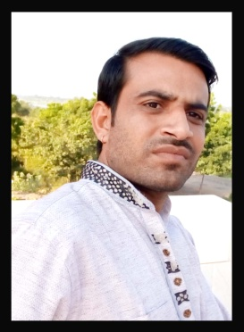
CURRICULUM – VITAE

Name:- Gyan
Gyan.357149@2freemail.com

Applied For

- EDP Clerks
- Cashiers
- Head Cashiers
Objective

To Find a job where I am able to put in to practice the experienced I have gained. Contribute to a theme effort working towards a united goal in a happy atmosphere where my efforts are recognized.

Personal Details:

Date Of Birth :- 04/10/1985
Nationality :- Indian
Religion :- Hindu
Sex :- Mail
Marital Status :- Married
Language Known :- Hindi & English

Educational Details:
- Master of Art from Rajasthan University, Jaiper in the 2010.
- B.Ed from Rajasthan University, Jaipur in the year 2009.
- Bachelor of Art from Rajasthan University, Jaipur in the year 2007.
- Intermediate of Commerce from R.B.S.E, Ajmer in the year 2001.
- Matriculation from R.B.S.E., Ajmer in the year 1999.

Computer Skill:
- ‘O’ Level from Doeacc University, New Delhi , 2005
- Diploma in ADCA From National Education of Technology & computing Socity,Sikar,
- Diploma in Computer application from RS-CIT, KOTA
Ms Office, (Word, Excel, Power Point).

Work Experience:

- Swami Vivekanand Sikshan Sansthan Kumas Jagir as a Computer Operator And UDC Clerk. (Two Year)
- COMMUNITY HEALTH CENTER,Nechhwa as a COMPUTER OPERATOR.(One year)
- Govt. COMMUNITY HEALTH CENTER,Garoda as a COMPUTER OPERATOR AND NETWORKING.(Two year)
- Swami Vivekanand Sikshan Sansthan Kumas Jagir as a UDC Clerk. (One Year)

IT Skills:
Windows & Office Tools
- MS Word , Excel Advanced
Typing Knowledge:

- English & Hindi
Personal Profile:
- Very energetic , result oriented and organized.
- Managed and supervise store perfectly.
- Efficient and well behaved person.
- Extremely hardworking self motivated and able to work independently in a team environment under supervision.
- Always focused on result oriented.

Declaration:

- Interested in social activities in the society.
- Inspection and handling products.
- Travelling and exploiting to strange destinations.
- I am always keep a good helping mentality.

In the above facts are true and correct to the best of my knowledge. If you could give a chance to work with you. I assure that I will discharge my duties to the entire satisfaction of your organization.

