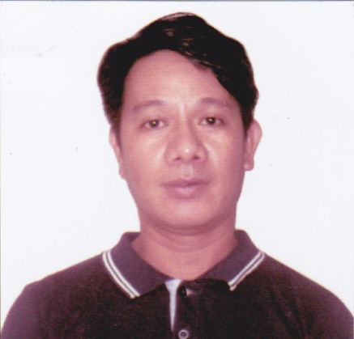
Alfredo
Alfredo.357151@2freemail.com

OBJECTIVE
Looking for a position as a Computer Hardware Technician and CCTV installer with a great troubleshooting skills and hardware knowledge to provide exceptional services to clients.
PROFILE
Age: 45
Date of Birth: October 2, 1971
Height: 5’5”
Weight: 60 kg
Civil Status: Married
Nationality: Filipino
Religion: Christian
Sex: Male
Language Spoken: Tagalog & English

EDUCATIONAL BACKGROUND
Tertiary
International Electronics and Technical Institute
Computer Technician and System Management
1992-1994

Secondary
Canumay West National High School
1986-1990

Primary
Canumay West Elementary School1981-1986
WORKING EXPERIENCE:
Expertlan Computer Center
Computer Technician
2001-2008
Apocalypse Computer Services
Computer Technician
2008-2012
Cyber Mechanic Computer Center
Technical Supervisor 2012-2017

KEY QUALIFICATIONS
• Over 16 years of experience as a Computer Technician
• skilled in repairing of all kinds of computers
• Hands on experience in installing and troubleshooting networks
• Proficient in installing Software and Hardware
SKILLS
• Excellent understanding of standard hardware issues and protocols
• Ability to work for long hours
Computer Hardware Technician
• Set up Hardware and install windows 7, Office 2007, Office 2010
• Fix standalone PC problems
• Work with wires and cables to ensure proper setting
• Diagnose problems using specific tools

OTHER SKILLS:
CCTV CONFIGURATION AND INSTALLATION
DRIVING

I hereby declare that the information furnished above is complete and true to the best of my knowledge.

