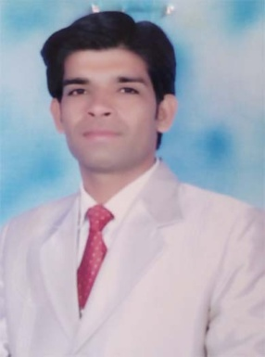
CURRICULUM – VITAE

Name:- Amar
Amar.357154@2freemail.com

Applied For

- EDP Clerks
- Cashiers
- Head Cashiers
Objective

To Find a job where I am able to put in to practice the experienced I have gained. Contribute to a theme effort working towards a united goal in a happy atmosphere where my efforts are recognized.

Personal Details:

Date Of Birth :- 11/08/1988
Nationality :- Indian
Religion :- Hindu
Sex :- Mail
Marital Status :- Married
Language Known :- Hindi & English

Educational Details:
- Master of Commerce from Rajasthan University, Jaiper in the 2012.
- B.Ed from Rajasthan University, Jaipur in the year 2011.
- Bachelor of Science from M.G.S University, Bikaner in the year 2008.
- Intermediate of Science from R.B.S.E, Ajmer in the year 2005.
- Matriculation from R.B.S.E., Ajmer in the year 2003.

Computer Skill:
- Diploma in Computer application from RS-CIT, KOTA
Ms Office, (Word, Excel, Power Point)
- Diploma in MS Office & Tally 9.0 From Accounting Institute,Delhi
- Diploma in DCA From Maa Karani Computer Centre,Ganeri ( Diploma With Computer Application )

Work Experience:

- Jaipur Rugs Pvt.Ltd.Company as a Marketing of the Product.( One Year Three Month )
- Shree Saraswati Sikshan Sansthan, Ganeri as a Computer Operator And UDC Clerk.
(Two Year)
- S.B Motors Sahepura as a Ass.Manager & Cashier.( at Persent )

IT Skills:
Windows & Office Tools
- MS Word , Excel Advanced

Typing Knowledge:

- English & Hindi

Personal Profile:
- Very energetic , result oriented and organized.
- Managed and supervise store perfectly.
- Efficient and well behaved person.
- Extremely hardworking self motivated and able to work independently in a team environment under supervision.
- Always focused on result oriented.

Declaration:

- Interested in social activities in the society.
- Inspection and handling products.
- Travelling and exploiting to strange destinations.
- I am always keep a good helping mentality.

In the above facts are true and correct to the best of my knowledge. If you could give a chance to work with you. I assure that I will discharge my duties to the entire satisfaction of your organization.

