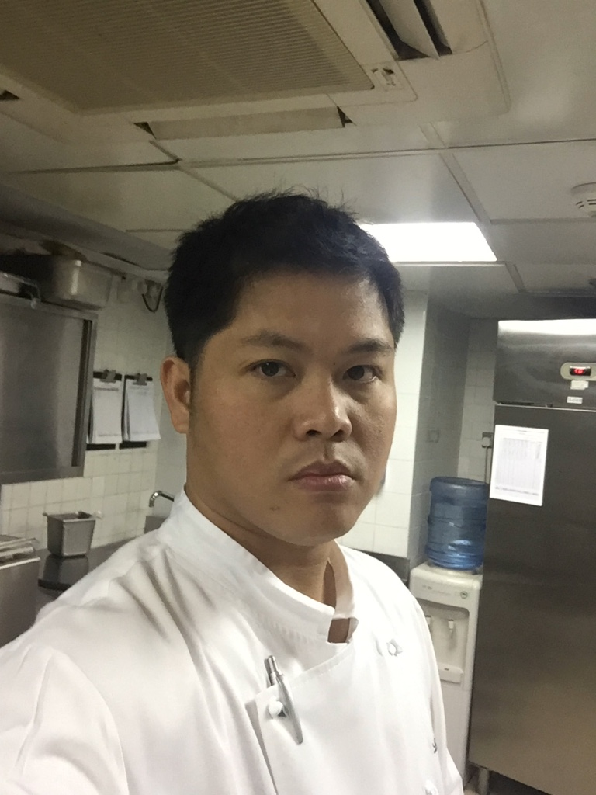

GEORGE
GEORGE.357161@2freemail.com
SOUS CHEF

PERSONAL SUMMARY
A hardworking, pro-active sous chef with a positive attitude, passionate about food and quality. Possessing excellent organizational skills, highly efficient and methodical with a good eye for detail.

KEY SKILLS AND COMPETENCES
- Offering professional, friendly and proactive guest service
- In depth knowledge of supervising multiple levels of culinary staff
- Hands on experience of advocating advance cooking techniques: Banquets, recipes, fine dining, menu development, catering, contemporary, Mediterranean, food preparation, food safety and butchery
- Friendly personality with a 'can do' attitude
- Responsible for stock control, purchasing and menu planning
- Ability to quickly identify and resolve problems
- Able to work overtime at short notice if required
- Ensuring that all HACCP reports are maintained and monitored.

CAREER HISTORY

Le Royal Meridien Abu Dhabi Stratos Revolving Lounge Bar and Grill
Sous Chef May 2014 up to present
Responsible for the smooth, efficient running of the kitchen, including its routine operations, food preparation and production, as well as supervising kitchen staff.
Duties:
- Assisting with the preparation of all food requirement
- Keeping all working areas and surfaces clean and tidy.
- Ensuring that all foods are produced in a safe and hygienic manner at all times.
- Making sure that foods are prepared and presented on time.
- Responsible for completing all audit and quality standards documentation.
- Cooking fresh food in a romantic and best commended European steak restaurant.
- Assisting with some administration duties and management of the team.
- Sometimes involved in catering for large conferences and banquets.
- Monitoring employee productivity & kitchen related costs to ensure efficiency.
- Dealing with any employee issues and queries.
- Making sure stock control and rotation procedures are implemented.
- Assisting with the training, management and development of the team.
Grand Heritage Doha Hotel and Spa Figus Italian Restaurant/Flavors All Day Dining
Junior Sous Chef April 2011 -May 2014

The Gramercy DIFC Dubai Pub and Sport Bar
Chef De Partie Sep 2010 – April 2011

Maze Gordon Ramsay The Pearl Contemporary Fine Dining
Chef De Partie Mar 2010 – Sept. 2010

Intercontinental Regency Bahrain Le Bistro All Day Dining
Demi Chef de Partie July 2009 – Mar 2010

Emirates Palace Hotel Abu Dhabi In Room Dining/Mezzaluna Italian Restaurant
Commis 1 Feb 2006 – May 2009

ACADEMIC QUALIFICATIONS

Tertiary School University of Cebu Philippines (UC)
Associate in HRM 1997 – March 2000

Secondary School Bitoon National Vocational School (BNVS)
Drafting Major 1991 – March 1995

AREAS OF EXPERTISE TRAININGS AND SEMINARS ATTENDED

Planning Menus & Production Train the Trainers Program Certificate
Kitchen Management Essential Food Safety Training Certificate (EFSTC)
Banquets, Fine Dining & Classic Dishes Fire Extinguisher Training, Safety and Procedures
Wastage Control & Menu Development Basic Food Hygiene Training
Sanitation Technique Skills Cert. Program for Banquet Servers and Set-Ups
Cleaning Kitchen Equipment
Health and Safety Procedures

REFERENCES – Available upon request

