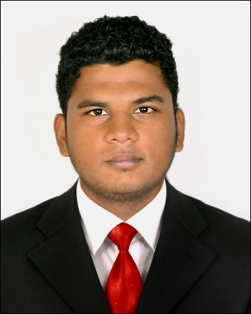

WEBSTER

Customer service/ Administrator
Email: Webster.357242@2freemail.com

Objective

To be professionally associated with an esteemed organization, with an objective to utilize my education and experience most meaningfully and work towards achieving the goals of the organization. And to help myself out in learning & improving my hospitality skills where I can use it to provide better customer satisfaction.

Skills

Excellent communication.
Co-ordination
Tourism & travel Management
Customer service/ relationship
Catalyst
Multitasking
Service Oriented
Team Work

Experience

Call Centre Executive • Jumeirah international

• 2015 Sep – 2016 Sep

- Answering all the calls by providing relevant details
- Handle customer enquiries both telephonically & by e-mail
- Effective & timely communication
- Verify Information & create work order requests on Prisma
- Sending the work order requests & follow up on the same
- Fulfills requests by clarifying desired information; completing transactions; forwarding requests
- Support engineering team in closing the requests
- Process orders forms & applications
- Follow up customer calls where necessary
- Identify & escalate priority issues
- Maintains call center database by entering information
- Handling requests for information and data and ensure emails/faxes/letters received are acted upon
- Maintaining a good rapport with the clients.

Client Servicing • Benchmark Media fz llc

• 2015 jan – 2015 sep

- Client Servicing
- Office Administrative works
- Event/Media co-ordination
- Production controller
- Manage client database & data entry
- Tele Marketing & social media marketing
- Prepare written response to all the enquiries by e-mail.
- Responsible for Vendor Management
- Co-ordinate maintenance of office equipment
- Prepare for client/ vendor meetings
- Schedule & co-ordinate meetings, appointments & travel arrangements for managers & supervisors
- Activities involving visa process, Booking Air-Tickets & Hotels for the guests.

Tour Operator • Club mithra holidays

• may 2011 – oct 2015

- Customer Service DEPT
- Design tour packages for the Guests
- Booking Hotels/ Houseboats & Venues for respective clients
- Marketing & Sales – South Malabar zone Kerala
- Worked as Tour Co-coordinator (Inbound).
- 6 months Interns - Club MITHRA Holidays.

Computer Skills
Microsoft Excel, Microsoft Word, Power-Point, Microsoft Outlook & Access.

Education

BSC.ATHM (Airline Tourism Hospitality Management)

• 2011 • Punjab technical university
Graduate in Tourism & Hospitality Industry from Chavara College of Tourism Studies.

12th Grade • 2008 • NIOS
Plus 2 in Deepa college.

10th Grade • 2006 • CBSE
SBOA Public school

Personal Information

Date of Birth 30-09-1992
Nationality Indian
Relationship Status Single
Date of Issue 15-12-2014
Date of Expiry 14-12-2024
Place of Issue Cochin, India.
VISA Status Visit (3 Months)
Visa Validity Feb 28th - May 27th

language

- Excellent Command of both written and Spoken English.
- Excellent Command also in Hindi, Tamil & Malayalam.

Declaration

I hereby declare that the above information’s are true and correct to the best of my knowledge and belief.

