Curriculum Vitae |  | ARUN
ARUN.357389@2freemail.co |  | 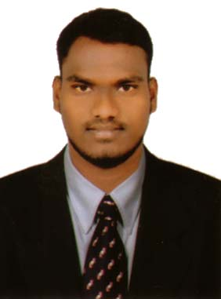
Objective

To grow with a leading organization that utilizes my abilities to the fullest extent possible, helping me realize and develop my potential and be a part of a team that scales great heights through continuous learning process and utmost dedication.

Experience

From June 2016 to August 2016 with Tata AIA Life Insurance Company Ltd.
Role: Wealth Planning Officer
Responsibility: Sales, Relationship Management, Customer Orientation and Reporting/MIS.

- From Feb 2015 to Dec 2015 with Zodiac Clothing Company Ltd.
Role: Customer Care Associate
Responsibility: Sales and Reporting.

Education

POST GRADUATION | MAY 2016 | MAHATMA GANDHIN UNIVERSITY, NALGONDA, TELANGANA, INDIA
- Course: M.B.A (Integrated) (74.00%)
- Major: Marketing
- Minor: Human Resources
- Related coursework: Business Management

INTERMEDIATE | JUNE 2010 | BOARD OF INTERMEDIATE EDUCATION, ANDHRA PRADESH, INDIA
- Course: M.P.C (62.7%)

METRICULATION | MAY 2008 | BOARD OF SECONDARY EDUCATION, ANDHRA PRADESH, INDIA
- Course: Secondary School Certification (81.0%)

Skills and Abilities

- Sales and Marketing
- Customer Support
- Relationship Management

Extra Curricular Activities

Actively participated in

- UGC sponsored National Conference on “Business Trends on New Era”

- National level student meet on “World Tourism Day” in my University campus.

- Participated in “SIESTA 2K13” A National level management meet conducted by Swami Ramanandha Thirtha Engineering College, Nalgonda, Telangana, India.

Project Work

MBA INTEGRATED (Post graduation project)
Completed project work on the topic SALES AND SERVICE in HARSHA TOYOTA COMPANY LIMITED, HYDERABAD, TELANGANA, INDIA.

Personality Information
Skills  Technical Skill | - Willingness to learn new things.  - Smart work with Hardworking ability.  - Ability to deal with people.  - MS Office and PGDCA
Personal Information
Gender : | Male.
Marital Status : | Unmarried
Nationality : | Indian.
Linguistic :  Hobbies : | English, Hindi, Telugu.  Reading Novels  Watching Advertisements and Movies  Playing Badminton  Gardening

Declaration

I hereby declare that the above furnished information is right with my best perception.

