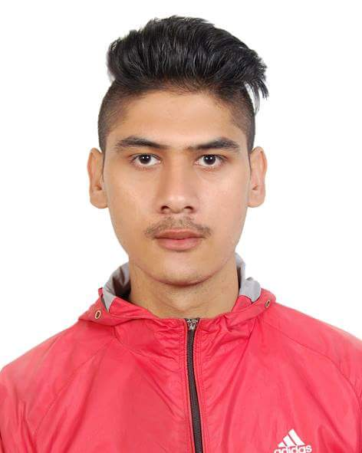
Curriculum Vitae
NAME: Dipak
Dipak.357420@2freemail.com

FUTURE GOAL | To become the best employee and see myself at the managerial level
QUALIFICATION | HIGH SCHOOL  Kist College of Magement  Kathmandu, Nepal  SCHOOL LEAVING CERTIFICATE  Buddha Himalaya Secondary School  Kavrepalanchok, Nepal
EMPLOYMENT  HISTORY | Waiter  Trader Vic’s Restaurant ( 2nd Jan 2013- 1st Jan 2015)  Riyadh, Saudi-Arabia  The Wind Bell Restaurant (3rd April 2015- 1st May 2016)  Kathmandu, Nepal
VISA DETAILS | Visa type: Long Term Visit Single Entry Issue date: 12 Feb 2017  Valid until: 09 May 2017
TRAINING AND  WORKSHOP | Trained as a Waiter in Trader Vic’s, Riyadh-Saudi-Arabia  Trained as a Waiter in The Windbell Restaurant, Kathmandu- Nepal
LANGUAGE | English: Fluent  Hindi: Fluent  Nepali: Mother Tongue
EDUCATIONAL ACHIEVEMENT | Name of Board | Passed Year | Name of institution | Division | Percentage
 | SLC | 2011 | Buddha Himalaya | 1st | 73.23
 | HIGH SCHOOL |  | KIST College of Management | Running
Duties and responsibilities | • Greet customers as they arrive at the restaurant and inquire into their seating preferences  • Gauge customers’ seating needs (by counting number of people in a party) and lead them to appropriate tables  • Assist customers in seating and provide them with menus  • Provide customers with information on revolving menu items and daily specials  • Leave customers for a little time to give them a chance to choose from the menu but keep an eye out for customer calls  • Answer questions regarding menu items and ingredients and provide information regarding diet items and specials  • Suggest appropriate wines and other beverages to go along with customers’ meals  • Maintain knowledge of any items that the kitchen may be running out of  • Take orders for lunch and dinner and repeat taken orders to ensure accuracy  • Inform customers about the time it will take for their orders to be prepared and served  • Relay orders to the kitchen and ensure that they are prepared according to recipe
OTHER ACHIEVEMENT | Employee of the month in Trader Vic’s in 2014  Winner in Intra-football cricket match in 2012  First runner up in district level quiz competition in SLC level  Community champion in the table tennis competition
HOBBIES | Sports, reading books, listening music, watching sports on tv, singing, hanging out with friends

