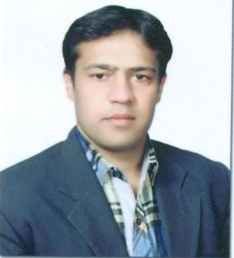
AFSAR
DHA Pharmacist Pharmacy
CELL#C/o 0501685421 afsar.357439@2freemail.com
experience
AGA KHAN HEALTH SERVICE PAKISTAN, -Incharge Pharmacy August 2014- December 30,2016
Ensure Pharmacy Operations related to Inventory Management, Ambulatory, and Inpatient Care Pharmacy Services.
Operating Reception and Accounts by performing Inpatient and out patent billing system during Evening/Night Shifts and Holidays
PERIODIC DUTIES AND RESPONSIBILITIES:
Member of Quality Improvement Committee, Unit ,Pharmacy & Drug therapeutic Committee

DISTRICT HEAD QUARTERS HOSPITAL SKARDU, Skardu— Hospital Pharmacist
May 2013- May 2014
Monitoring the Pharmacy stores regarding to assure Quality Assurance Parameters.
Ensuring daily and weekly Performa’s and distribution for proper consumptions of Drugs.

HEALTH &PHARMACY, Gilgit—Retail Pharmacist Oct 2011-May 2013
E Ensure Good Pharmacy Practice related to Quality Assurance, Inventory Management to dispensing.

WILSON’S PHARMACEUTICAL, Islamabad—Quality Assurance officer Feb 2010 -July 2010
Monitor and support Production department to assure the Quality and Stability of raw material to finished Product by physical evaluation and analysis. Maintain proper Validation and follow-up of cG.M.P and ensure ISO standard.
training/workshops/serviCes
Aga Khan Health Services Pakistan | Pharmacy &Purchase Department | Pharmacy $ Purchase Workshop | 3 days, 2014
Community Emergency Response Team for Skardu training organized by Focus Humanitarian Assistance.
Publication “Drug Abuse/Substance Abuse(Alcohol & Tobacco) edition 2014
Honorary Secretary of Shia Imami Ismaili Local Council for Skardu
education
Doctor of Pharmacy (PharmD) from University Of Karachi.(2004-2009):
Pharmacology, Pharmaceutics, Pharmacognosy, Pharmaceutical Chemistry, Pharmaceutical Management and Marketing.
Intermediate from D.J Sindh Govt. Science College, Karachi.(2002-2003)
Matriculation from Aga Khan School Garden, Karachi.(2001)
computer skills
Well versed in using PC
MS office, Internet Exploring, & Hardware

languages
English, Urdu,Hindi,Brushaski & Balti
PERSONAL data
Date Of Birth : 10th March 1986
Marital Status : Married

