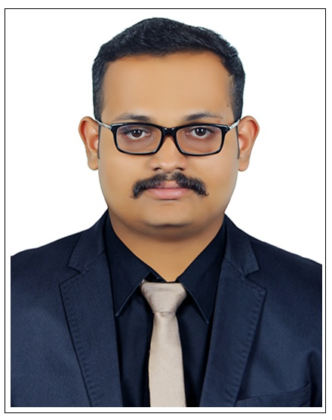
IBRAHIM
1 Year and 6 Months Professional Experience

B.Tech , Computer science And Engineering

Microsoft Certified Solution Expert.

Contact no: C/o 0502360357
Email: ibrahim.357474@2freemail.com

CAREER OBJECTIVE

To work in a firm with a professional work driven environment where I can utilize and apply my knowledge, skills which would enable me as a Computer Hardware Engineer and to grow while fulfilling organizational goals.

BASIC ACADEMIC CREDENTIALS

- Microsoft Certified Solution Expert (2015)
Qualification | Board/University/institution | Year | Percentage
B.Tech (Computer  Science Engineering) | University -Mahatma Gandhi university | 2010-2015 | completed
,kottayam

Institution – Jai Bharath Collage Of Engineering And Management Technology
Higher secondary  school certificate | Board - Kerala state board  Institution – NSS Higher Secondary School | 2008-2010 | 65%
Secondary School Certificate | Board - Kerala State Board Institution – devaswom board high school | 2008 | 86%

WORK EXPERIENCE

May 2015 – Nov 2016 Globosoft Technology Solutions. Hardware/system
Administrator

Globosoft technology solutions is an Indian based Software And Systems Development company specializing in creating custom IT solutions for clients around the world. My job role is for technical delivery of system development based work throughout the enterprise and to maintain, troubleshoot Network connection and hardware systems. Additionally, I fulfill client facing Problems as technical expert and Computer hardware consultant.
Reference : George Thomas Kochery Designation : HR – Head
george@globosoft,in, +918086677990 www.globosoft.in
TECHNICAL KNOWLEDGE

- Very well knowledge in Computer Hardware assembling.
- Excellent knowledge in computer repairing and maintenance.
- Very well knowledge in Operating System installations of windows , linux etc..
- Excellent knowledge in system drivers and devices
- Excellent troubleshooting skills in complex software and hardware problems..
- Excellent technical skills in Computer Networks(Microsoft) .
- Fair knowledge in Microsoft Office Word, Microsoft Office Excel, Microsoft Office Power Point. .
- Programming Languages : C ,C++,Java ,PHP - intermediate
- Good skills in online Support to customers concerning their computer software and hardware problems.

PROJECT DETAILS

Completed MINI PROJECT as a part of course study, topic ONLINE INSURANCE PORTAL

Description: The project deals with web based application which is mainly developed for the agents of the insurance company to take the policy for his clients electronically. This system can facilitate online processing and provides services to insurance partners.

Completed MAIN PROJECT as a part of course study, topic CREW MANAGEMENT with the supervision of IBM.

Description: The project is an application designed to be used by Field Officer for reduce his effort.

ACHIEVEMENTS

- 1st prize winner in 48th Kerala State Kalotsavam 2007-2008 in group event DRAMA.
- Selected and worked as publicity convener in National level Engineering Technical (Prayukthi’14) fest held by collage.
- Actively participated and won prizes in various arts and sports activities for inter school, collage competitions.

INTERPERSONAL SKILL
- Highly skilled in creating user guidelines and troubleshooting technical manuals.
- Excellent organizational skills and ability to prioritize workload.
- Excellent communication skills.
- Enthusiastic self-starter who contributes well to the team.
- Ability to work in a fast-paced environment to set deadlines.
- Confident and Determined

Ability to cope up with different situation

PERSONAL DETAILS

• | Date of Birth | :- | 15th november1990
• | Gender | :- | Male
• | Languages Known | :- English , Hindi , Malayalam
• | Driving liscence | :- Indian
• | Marital Status | :- | Single
• | Nationality/Religion | :- | Indian/Islam
• | Interest & Hobbies | :- | Internet Surfing, Gadgets and latest technology enthusiast,
Puzzles,Movies,Sports,Travelling.

DECLARATION

I do hereby declare that the above information is true to the best of my knowledge.

Place: Dubai

Date: 26/03/2017 Ibrahim

