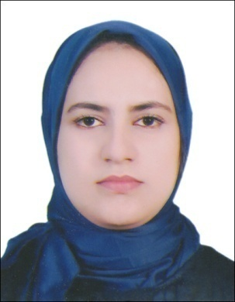
Maram
Maram.357598@2freemail.com

PROFESSIONAL SUMMARY
Energetic, motivated Personal Assistant who is highly organized and skilled at balancing the needs of clients in both personal and professional capacities. Strong work ethic and positive attitude. Highly effective in fast-paced work environments.
SKILLS
Fluent in French Excellent planner and coordinator
Microsoft Excel certified Certified Computer Office Assistant
WORK HYSTORY
May 2015 to August 2016
Accountant
DELTA CONSEIL El Jadida, Morocco
- Managed the CEO s complex and frequently changing travel arrangements and coordinated the pre planning of trips.
- Compiled and analyzed sales and marketing reports.
- Managed external contacts for CEO and kept track of periodic communication needed for priority contacts.
- Directed administrative function for the directors, principals, consulting and key managers.
- Distributed company-wide announcements, booked conference rooms and coordinated catering for annual staff development forum.
- Developed and maintained and internal client system.
September 2013 to March 2015
Account Assistance,
E.S.I.M.A, High School, El Jadida, Morocco
EDUCATION
November 2014 to May 2015
Professional Training
DELTA CONSULTING, El Jadida , Morocco
Coursework in Office Accounting, Computer Applications, Spreadsheets, Business Communications, Composition, Keyboarding, Office Techniques, Strategies for Success, Career Skills, Word Processing, Information Processing
- Bachelor’s degree of Business Administration
University Chouaib Doukkali, Polydisciplinaire- El Jadida, Morocco\ Academic concentration in business and management.

