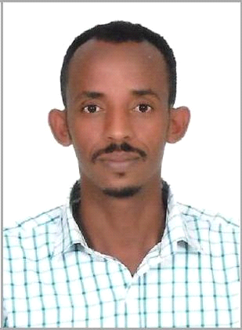CURRICULUM VITAE

Name: Debesay
Debesay.357663@2freemail.com

Dubai, UAE
OBJECTIVE
Seeking a challenging teaching position in a progressive and dynamic organization, where my knowledge, skills and work experience could be utilized in the most productive, innovative & resourceful manner and also provide growth, training and career development opportunities in the field.

KEY COMPETENCIES
- Substantial knowledge of child growth/development and behaviour characteristics

- Able to develop and implement regular academic programs and social activities with special focus on promoting curricular goals

- Solid knowledge of conceptualizing the broad goals of a school aimed at facilitating organizational efficiency

- Successfully designed new syllabus for increased productivity.
- Demonstrate ability to communicate to students and parents in a positive manner

- Excellent public speaking and presentation abilities.
- Proficient in all major computer operating systems.

- Takes a comprehensive approach to every task

- Can work well in stressful, high pressure situations.
- Ability to make progress on multiple assignments under time constraints.

WORK EXPIRENCE
Sep 2012 – Aug 2016 Sagem Secondary School, Teseney - Eritrea.

Position: Dep. Head

Aug 2009 – Mar 2012 Warsay Yikalo Secondary School, Sawa – Eritrea.

Position: Teacher.

Sep 2006 – June 2009 Denden Secondary School, Asmara - Eritrea.

Position: teacher

Duties & Responsibilities

- Prepares course objectives and outline for course of study following curriculum guidelines or requirements of state and school

- Develop lesson plans and teaching aids and ensure appropriate implementation.
- Teaches students Biology skills in school.

- Lectures, demonstrates, and uses audiovisual teaching aids to class. Motivate students to enjoy their sessions more by inviting speakers to class who spoke about the relevance of their course.

- Assess students’ progress daily in concepts rendered class.

- Maintains order in classroom. Counsels pupils when adjustment and academic problems arise

- Discusses pupils’ academic and behavioral attitudes and achievements with parents.

- Keeps attendance and grade records as required by school.
- Ascertain appropriate scheduling of staff and ensure that schedules are followed appropriately.

- Organize and facilitate the management of educational and social activities.
- Act as a point of contact for students’, parents’ and staff’s grievance addressing needs.

- Handle recruitment and training of teaching and support staff.
- Create and implement admissions and registration procedures.

- Assist students in choosing between subjects and coordinate assessments and examinations.

LANGUAGE SKILLS
- Englis h:- excellent(reading, listening, speaking and writing)
• Arabic :- excellent (reading, listening, speaking and writhing)

- Amharic:- excellent (reading, listening, speaking and writhing)

- Tigrigna:- Mother Tongue

EDUCATIONAL BACKGROUND
- Bsc Degree in Biology
- Certificate in Computer Application

- Certificate in Computer Maintenance and Networking

HOBBIES
- Reading Books

- Listening Music
- Travelling

DECLARATION
I hereby declare that the above information is true and correct to that best of my knowledge and believe.

