Sundaram Roshini

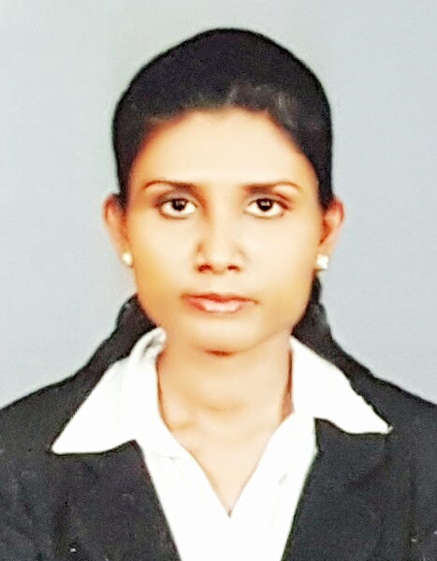
Tel: C/o 0505891826
E mail: roshini.357723@2freemail.com
Date of Birth: 06th December 1988
Gender: Female
Civil Status: Single
Nationality: Sri Lankan
Visa status: Visit Visa

To develop a suitable career in a growth-oriented, Progressive organization, where I will be a valuable team member, contributing quality ideas and work to my ability.

EDUCATIONAL QUALIFICATIONS

School Attended

- St’ Joseph’s Balika Maha Vidyalaya - Colombo-14

G.C.E. Advance Level (2008)

Subject Grade

Accounting C
Business Studies C
Economics C

- Good Shepherd Balika Maha Vidyalaya - Nayakakanda

G.C.E Ordinary Level (2004)

Subject Grade

Religion A
English B
Sinhala C
Mathematics S
Science S
Social Studies C
Commerce S
Art S

PROFESSIONAL QUALIFICATIONS

- Institute Of Human Resource Advancement - University Of Colombo (IHRA)
Successfully completed the Certificate Course in English Language Intermediate Level and Higher Level examinations

- MPC Computer college, Wattala
Successfully completed The Certificate in computer Application Assistant Course

- 3d mind Multimedia Training Centre, Kiribathgoda
Successfully completed The Certificate in Graphic Designing Course

CAREER EXPERIENCE

Working as a Customer Relation Executive at Ceylinco Life Limited, Sri Lanka from 1st of March 2013 year.

MAJOR JOB RESPONSIBILITIES HANDLE

- Assisted customers with their queries and problems via phone, e-mail & social media and do follow ups for required cases.
- Convinced the customer and resolved customer complaints.
- Achieved set targets of the firm by the stipulated deadline.
- Established and maintained contacts with new and existing customers as per the direction of the company standards.
- Helping to the sales persons by generating leads.
- Utilize computer technology including CRM systems to handle customer service.

LANGUAGE FLUENCY

- English

- Sinhala

- Tamil

EXTRA CURRICULAR ACTIVITIES AND CERTIFICATES AWARDED

- Successfully completed The Course Of Media and Leadership In Kandy Diocesan Media Centre.

- Member Of Under 19 School Netball Team.

I declare that the particulars given above are to the best of my knowledge and beliefs are true and accurate. I further declare that if I am selected, it shall be my earnest endeavor to discharge my duties efficiency and to the entire satisfaction of my superiors.

Roshini

