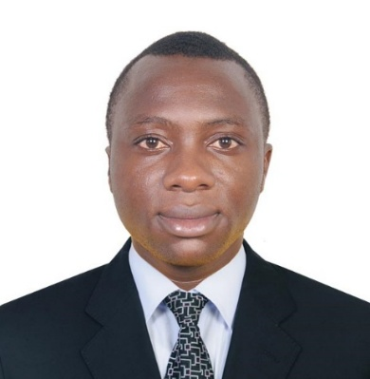
FONCHA
DATE OF BIRTH: 24/12/1992
NATIONALITY: Cameroonian
MOBILE: C/o 0505891826
EMAIL: foncha.357735@2freemail.com

PROFILE
Increased company sales by 15.5% over 3 years and efficiently completed all assigned tasks using expert customer handling skills with a team of 10 colleagues. I have an active, engaging and optimistic personality with a core believe that all levels of success can be achieved through constant effort.

EDUCATION
- Secondary school Certificate, Bamenda Cameroon
- High school certificate, Bamenda Cameroon
- Bachelors degree
- Food and hygiene safety program
SKILLS AND ACHIEVEMENTS
Position: CASHIER / CUSTOMER SERVICE
Company: NEXTLEVEL HOSPITALITY DUBAI U.A.E
Duration: 2015 – 2017

Position: Sales Executive
Company: GODWILL RETAIL AND WHOLESALE ACCESSORIES SHOP
Duration: 2012- 2014

Responsibilities
- Increased company sales by 15.5% over 3 years and efficiently completed all assigned tasks using expert customer handling skills and managing a team of 10 assistants.
- I have Perfect English and French writing and speaking skills and have contributed in the creation of more than 20 captivating adverts for some of our brand products.

- I am dexterous in writing and presenting accurate sales reports and current market analysis testament to my very fast typing (greater than 50WPM and 98% accuracy), and ability to edit and format different types of documents.

- Able to exhibit various products to clients and smartly present the benefits they will enjoy when they buy the products; many actually end-up buying.

- I have an engaging personality as I have demonstrated an ability to create instant functional relationships with client’s right from first contact.

- I hold a remarkably engaging, responsible and hardworking personality with utmost respect for individual and demographic differences.

- Mindful that dressing conveys a lot about ones personality, I am committed to dressing conservatively and appearing smart and professional at all times.

LANGUAGES
English – Read write and speak fluently
French – Read write and speak fluently

COMPUTER / IT SKILLS
- Microsoft office WORD-Excellent
- Computer Maintenance and Upgrade - Excellent
- Very fast typing greater than 45 WPM
- Internet Explorer

