Bhavini 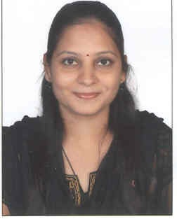
Female, 32 Years, Married.
Mo.C/o 0502360357
Bhavini.357757@2freemail.com

Objective:
To excel my career in the field of Teaching , in an organization that offers an opportunity for Mutual Growth.

Work Experience:
Organization: CADD CENTER, Andheri.
Duration: since November 2012 TO August 2014
Profile: As a faculty[Teaching “AutoCAD,AutoCADElectronic designing softwares(OrCADCapture,Pspice,PCB Editor)]

Organization: ANADIGI Control, Byculla, Mumbai.
Duration: 1 year [from aug 2007 to aug 2008]
Profile: Design, Development & Testing of microcontroller based embedded applications including hardware & software.

Qualification:
M.E.[Electronics] from Mumbai university – Appeared for second year.

B.E.[Electronics] from YadavraoTasgaokar Institute of Engineering &Technology,Bhivpuri Road[Mumbai university] with 61.4% in 2012.

Diploma in Electronics Engineering from Govt.PolytechnicBandra, Mumbai with 61% in 2008.

SSC from Maharashtra board with 67% in 1999.

Other qualification:
Master Diploma In Electronic Design Automation [SKETCHING-2D, ORCAD CAPTURE, ORCAD PCB EDITOR, PSPICE].

Diploma in Software Testing course from SEED(Manual testing, Automation tesing- QTP,QC,selenium,Bugzilla,Testlink).

Completed Oracle-SQLfrom NIIT.

Project details:
- VLSI based accident control [B.E.]
- Microcontroller based “Automatic toll tax system using RFID technology”[diploma final year]
- Electronic door security system with alarm[T.E.]
- Comparator, Zero crossing detector,3 bit up/down counter [S.E.]

Technical Skills:
- C, C++, Java
- Assembly language
- Metlab
- PCB express

Achievements:
- Participated at state & district level project exhibition cum competition
- Passed Intermediate grade drawing examination
- Passed two levels of BharatNatyam

Extra curricular:
- Painting
- Cooking

