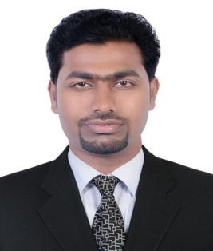  MUSTHAFA  DUBAI - UAE  Mobil :-C/o 0504753686  Email:- musthafa.357787@2freemail.com  Personal Data:-  Date of Birth : 16/11/1988  Nationality : Indian  Marital status : Married  Religion : Muslim | WQAWH  Objective: To take on challenging responsibility and utilize my experience and knowledge to the full extent. My strength is hard work and dedication with an inner drive to succeed and accomplish goals.  Academic Qualifications  - M.A Arabic : M.G University, Kerala, India  - B.Ed : Calicut University, Kerala , India  - B.A Arabic : Calicut University, Kerala , India  - Secondary : Board of Higher secondary, Govt. of Kerala  Working Experience  - 4 Year Working Experience as PRO&Typist(Labour,Immigration and Economic  - I have been working at You First Facilities Management Services L L C as PRO In Dubai UAE  - Profession: Public Relation Officer  - Two year working experience as teacher at Ilahiya Higher secondary school, Kerala, India.  Duties :-  - Labour, Immigration and economic works,  Lobour (Thasheel)  Immigration (Evision & Ednrd)  Economic (License related works)  - Medical & Emirates ID Typing.  - Memorandum of Association (LLC , Civil Company) and It`s Amendments. Appointment Contract of Local Service Agent ( Sole Establishment)  - Power of attorney (General & Special)  - mutual agreement and court papers  - Letter making and drafting,  - Documents clearing,  Duties and Responsibilities  - Administration  - Documentation  - Data entry  - Customer Services  - Dealing and Managemanting

CURRICULUM VITAE

Languages Known
- English
- Arabic
- Hindi
- Urdu
- Malayalam

Computer Background:-
Good Knowledge in MS Word, MS Excel and Windows
DTP
Internet
Typewriting Awareness in English&Arabic
Strength
- I have done a course on Diploma in functional Arabic (2 years)
- I have done a course on Muthawal in Nizami from Jamia Nizamia Hyderabad

Strength
- Excellent leadership qualities
- High situational awareness
- Ability to work under stress and deliver results.
- Willing to learn modernization and eager to expand new horizon.
- Sincerity commitment, motivation and ability to plan for the assignments undertaken.
- Effective communication skills
- Professional in appearance and presentation.
- Dedicated and strong desire towards learning.

I hereby declare that all the information given above is true and correct to the my knowledge and promise to pay my fullest effort in achieving organizational goals

Place: Dubai
Date: MUSTHAFA

