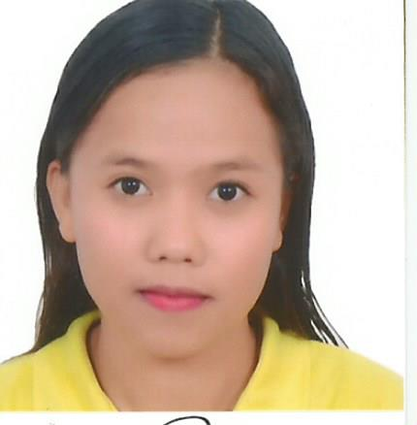
LIEZEL
Liezel.357921@2freemail.com

OBJECTIVE
Seeking for a job to pursue a well satisfying career and healthy work environment where I can utilize my skills and knowledge efficiently for the organizational growth.

PERSONAL DETAILS
Age : 25 years old
Nationality : Filipino
Date of Birth : November 25, 1991
Gender : Female
Civil Status : Single

EDUCATIONAL ATTAINMENT

VOCATIONAL INNOVATE ICT SYSTEM, INC.
Tacloban City, Philippines
Computer Hardware Servicing
(July 21- August 25, 2014)

TERTIARY EASTERN VISAYAS STATE UNIVERSITY
Tacloban City, Philippines
Bachelor of Science in Information Technology
(June 2010- May 2014)
Bachelor of Science in Environmental Science
(June 2008- October 2009)

SECONDARY STA. MESA NATIONAL HIGH SCHOOL
Dagami Leyte, Philippines
(June 2004- March 2008)

PRIMARY BUNTAY ELEMENTARY SCHOOL
Brgy. Buntay Dagami, Leyte, Philippines
(June 1998- March 2004)

EMPLOYMENT RECORD

National Irrigation Administration
Leyte Irrigation Management Office
Tacloban City, Philippines
Research Assistant B
(May 18, 2015-December 31, 2016)

Philippine Red Cross Leyte Chapter
(Qatar Red Crescent)
Tacloban City, Philippines
Community Facilitator (Volunteer)
(September 1, 2014 - March 4, 2015)

Philippine Red Cross Leyte Chapter
Tacloban, City, Philippines
Data Encoder
(June 2, 2015 - July 25, 2014)

EASTERN VISAYAS STATE UNIVERSITY (Accounting Office)
Tacloban, City, Philippines
On The Job Training (OJT)
(April 15, 2013 - June 29, 2013)

COMMISION on ELECTION (COMELEC)
Dagami Leyte, Philippines
PCOS Technical Support
(May 13-14, 2013)

DEPARTMENT OF SOCIAL WELFARE & DEVELOPMENT (DSWD)
Dagami, Leyte, Philippines
Enumerator
(April 15, 2012- June 15, 2012)

TRAININGS/ SEMINARS ATTENDED
STAFF DEVELOPMENT TRAINING
National Irrigation Administration
Ormoc Villa Hotel
Ormoc City, Leyte, Philippines

INFORMATION and COMMUNICATION TECHNOLOGY (ICT) ROAD SHOW
Tacloban Convention Center
Sagkahan , Tacloban City, Philippines
(March 18-19, 2014)

COMMISSION ON ELECTION
PCOS TECHNICAL SUPPORT TRAINING
Leyte Park Hotel, Tacloban City, Philippines
(April 4-6, 2013)

NATIONAL IRRIGATION ADMINISTRATION
Systems Management Training
Balay Alumni,VSU, Baybay City, Leyte, Philippines
(October 17-19, 2012)

SKILLS
- Public Speaking
- Networking
- Operating System: Windows XP, 7 and 8, 8.1 and 10
- MS-Word, MS-Excel, MS-PowerPoint

- Basic Computer Hardware Servicing

