ROSHNI
C/o 0505891826
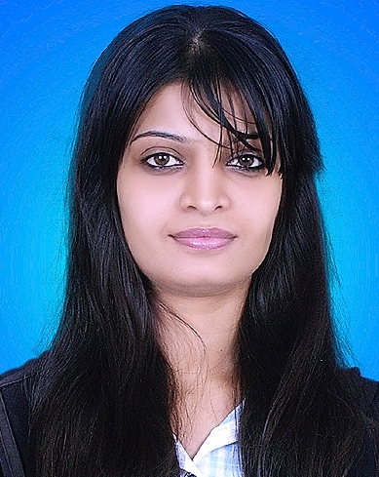
DOB: 22-November-1990 Languages: English, Urdu
Email: roshni.357930@2freemail.com Marital Status : Single

November 2013 - till now: Joined QMobile as a CRO in branch and then promoted as a CCS (Branch in charge in Clifton) in Oct 2016 and working till now.
August 2013-November-2013: As a CSR in Warid Telecom Franchise (Delta communication) Still working.
January 2012- August 2013: As a CSR in Mobilink Franchise (Weblink Telecom 7015).
June 2011-January 2012: Era Automation & Lab (pvt) Ltd, (as a Calibration Coordinator)

EDUCATION:
B.A : Karachi University
Metric 2008 : St Mary’s High School
Intermediate 2010 : In Pre-engineering

SKILLS:
MsOffice 2010 : Window Xp, and windows vista 7.
: Knowledge of PC platform.
Graphics : Adobe Photoshop, Microsoft Power point, Adobe Illustrator, Adobe
Software’s : Oracle, Tab’s, Siebel

Leadership skills: Planning & management
Interpersonal & communications excellence

DISCREPTION OF JOB:
ERA AUTOMATION: Multinational companies deleing
Manufacture companies deleing,
Making Quotations, Invoices, and all office work.
MOBILINK & WARID FRANCHAISE: Customer cares Services Representative
- Present working status and job responsibility.
- Responsible for attending the given targets on time.
- Making daily, weekly, and monthly reports.
- Provide customer service.
- Good command in Mobilink operating system “SIEBEL”.
- Good command in Warid operating system “TABS”.

AIM:
I want to utilize my all skills and want to take initiative for creative ideas for my organization and my goal is to increase the market share of my organization through using new and attractive tools.
I am highly capable, seeking an employment opportunity at the particular department I am applying for. I believe my passion for success, a positive attitude, commitment to professional growth and capacity for hard work are factors that make me eligible for suitable opportunity at your organization. I have enclosed my up to date Resume for your appraisal. You will see from my resume that I am adept at applying myself to a wide variety of responsibilities and I know I would be an ideal candidate for your consideration.

