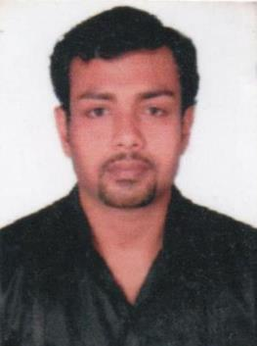
CURRICULUM VITAE

VINEETH
VINEETH.357957@2freemail.com

CAREER OBJECTIVE

To earn and learn with high degree of quality, integrity, commitment and responsibility in a challenging and rewarding environment in a progressive organization with professional approach, fine tuning of my skills and abilities leading to the integrated development of both the organization and myself.

EDUCATIONAL QUALIFICATION

S.S.L.C | : | Board of Public Examination, Kerala.
PLUS TWO | : | Board of Higher Secondary Examination.

COMPUTER KNOWLEDGE

- MS–Office (Word, Excel, Power point).

- Photoshop

ADDITIONAL QUALIFICATION

- Pre – Sea Course for GP Ratings With Indian CDC

- Personal Survival Techniques (2010)
- Personal Safety& Social Responsibilities (2010)
- Fire Prevention & Fire Fighting (2010)
- Passenger ship familiarization

- Elementary First Aid (2010)
- Security training for Seafares with designated security duties (2010)
- Basic Computer Applications
- Automobile Engineering

KEY STRENGTH

- Hard work, Punctuality, Team work, Customer service & Customer care skill & creative thinking.

WORK EXPERIENCE

- Worked as Security officer in Transguard LLC, Dubai from 2015-2016

- Worked as Office Assistant in Power Print Printing Press LLC, Dubai from 2011 to 2015

- Worked as Office Assistant in Patchi LLC, Dubai from2007 to 2010.

- Worked as Sales Executive in India today (DSD-Division-2011) Kerala responsible for Electronics and books division.

.

PERSONAL SKILL

Ability to learn and develop various jobs in a short period has a friendly nature. Maintain excellent

customer’s relations, ambitious and self motivated.

PERSONAL QUALITIES

Hard worker, Keen learner, Good inter relationship, persistence in work, perfectionist,

Disciplined and honest, prepared to sit late hours to active a goal of cool and confident

nature, takes criticism in the correct spirit to improve the weaker areas, God fearing.

COMPUTER SKILL

Basic knowledge and experience in computer application packages-MS-Word, Power point, Excel. Knowledge and experience with using internet and e-mail.

STRENGTHS

- Good interpersonal skills
- Ability to rapidly build relationship and set up trust

- Presentation skills

- Self-confident

- Good analytical skills & Quick Learning abilities

- Creative in approach

- Industrious and Good team player
- Customer service

PERSONAL DETAILS

Age & Date of Birth | : 30/12/1984
Nationality | : | Indian
Sex | : | Male
Marital Status | : | Single
Religion | : | Hindu.
Languages Known | : | Malayalam, English & Hindi

DECLARATION

I hereby declare that the above given details are true and accurate to the best of my knowledge.

VINEETH

