FATHIMA.358060@2freemail.com
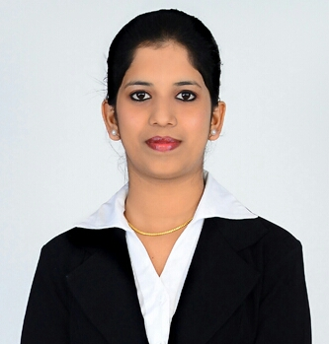  FATHIMA | Career Objective  A highly-motivated, extrovert and customer-focused team player with strong communication, interpersonal, organizational, time management, problem solving skill,fierce determination and perseverance in achieving set goals. where, I could shoulder the job responsibilities in the professional environment and attain self growth as well.  Educational Qualification  - DOA ( Diploma in Office Application) in Computer Application  - 2007-2008 : BTEC HNC (Edexcel UK) in Frankfinn Institute of  Airhostess Training, Coimbatore  - 2007-2010 : B.Sc Catering and Hotel Management in  Hindusthan College of Arts & Science, Coimbatore  Work Experience  - Front Office Administration (Designation) in Joseph and Joseph Associates in Gudalur from March 2014 till Dec 2016  - Handling clients queries and Administrative duties  - Assists Attorneys and Paralegal with managing schedules  - Responsible for Documentation and Files  - Coordinating meetings and appointments, manage schedules including trial dates, hearings and attending calls  Certifications  - FRANKFINN INSTITUTE OF AIRHOSTESS TRAINING:  - Successfully completed one Year course in Aviation, Hospitality and Travel Management  - Galileo CRS basic and Advanced Course  - In-flight training in Jet Airways charter flight number 9w8035 and has been familiarised with in-flight cabin crew operations, airport ground handling services including check-in, security procedures and arrival services  - English Edge programme with the certification of BBC  - Participated in the "Udaan-2008 Customer Interaction Project" covering areas of Real Life Customer Interaction & Service, Leadership Training and Team Work  - HINDUSTHAN COLLEGE OF ARTS & SCIENCE:  - Certified with Degree course in B.Sc Catering Science & Hotel Management First class with Distinction  Industrial Exposure Training :  - Industrial exposure training in TAJ MALABAR (Five Star Property) at Kochi, “Taj Group Of Hotels” for a period of four months  - In-flight training for Ground Handling and Cabin Crew in JET AIRWAYS (Chennai to Hyderabad) by Frankfinn Institute of Airhostess Training  Hands on Computer  - Proficient in MS Windows, MS Word, MS Excel, MS PowerPoint, Internet Explorer, Galileo and Fidelio  Achievements:  - Secured University 3rd Rank in Bharathiar university  - 1st Place in Paper Presentation on “ HR ”  - Had participated state level seminar in “A Day with a chef ”  Area of interest :  - Front Office (Customer oriented)  Other Skills :  - Good communication skill  - Pleasant Telephonic Ethics  - Tri-lingual person  Linguistic Skill :  Language Reading Writing Speaking  Tamil  English  Malayalam  Arabic  I assure that the above furnished information is true to my knowledge and if given an opportunity will exhibit my best efforts at all times

