Abdul
Abdul.358094@2freemail.com
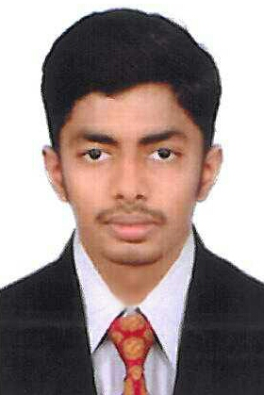
Career Objective/Summary | - A commerce graduate from the University of Calicut, looking to secure a document controller or accountant or Admin assistant position similar to utilize my current analytical skills and knowledge and also help me to further develop these skills in a practical and fast-paced environment.  To gain the position of a document controller or accountant where my professional experience can make extensive contribution towards the growth and benefit of the organization.
Work Experience | Document controller-Haramain High Speed Railway Project, @ MASCO, Jeddah, Saudi Arabia  (since March 2011 –2016 )  Keys & Responsibilities:  - Assisting in coordinating the activities related to document control including auditing and distribution of controlled documents, maintaining electronic department and tracking and reporting document review progress.  - Managing the archival activities for controlling documents and validation of documentation files.  - Working independently to facilitate work group activities in the department.  - Working with subject matter professionals on technical subjects in a collaborative, positive manner in preparing controlled documents that conform to require define formats.  - To control all non-administrative documents such as issued for construction drawings, specification, instructions and procedures received from clients, subcontractors suppliers as well as documents originated by the company.  - Receiving & distributing incoming and outgoing documents and mails.  - Distributing AutoCAD drawings and updating in logs on daily basis.  - Updating data on share point.  - Making purchase request in oracle.  - Create and maintain tracker for drawing approval process and technical submittals.  - Assist PM in preparation of monthly reports.  - Making daily reports of Head office and submitting to consultant.  Account Assistant (Sales tax consultants & practitioners)  (2010 – 2011)  Keys & Responsibilities:  - Managed all of administrative support in marketing department & conducted research in marketing strategies.  - Managed invoicing and billing process.  - Handle data entry and general ledger work as well as book keeping and general clerical duties.  - Handle Bank book and cash book entries  - Help to generate finance statement
Education | - Bachelor of commerce (B.Com) from University of Calicut, Kerala, India  - Secondary School Leaving Certificate Board of public Examination, Kerala  Subject specialized:  - Business statistics  - Managerial economics  - Information technology for business  - Financial accounting  - Business & Corporate laws  - Business management  - Banking theory  - Business communication  - Marketing management  - Entrepreneurial development  - Auditing  - Cost & Management accounting  - Income tax  - Co-operation  - Business practice and development  Other Qualifications:  - Computerized Accounting with Tally  - Accounts management  - M S Office (word,excel,outlook)  - Share point  - Oracle  - SAP – ERP-FINANCE  - ACONEX
Skills and Achievements | - Energetic and hardworking  - Communication skills  - Positive thinker  - Confident in handling assignment
Hobbies and Interests  Personal Profile | - Reading  - Travelling  Date of Birth : 25-05-1989  Age : 27  Sex : male  Religion : Islam  Nationality : Indian  Languages Known : English, Hindi, Arabic & Malayalam

Declaration | I hereby declare that all details furnished are true and correct to the best of my knowledge and belief.

