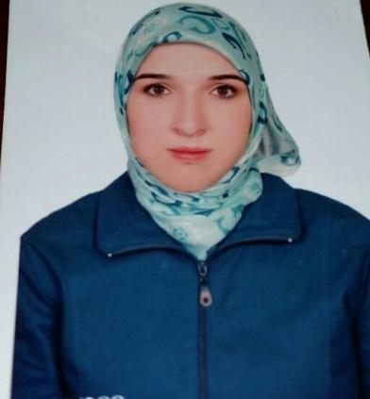 | Contact:  C/o 0502360357  hiba.378175@2freemail.com

Personal Information:  - DOB: 10/1/1987 (Damascus, Syria)  - Married  - Resident visa (Abu Dhabi) | Education:  Bachelor degree in Islamic Studies 2007-2008  Bachelor degree in Translation 2008-2009

Language skills:
English - Fluent Conversational

Computer skills:
ICDL Degree (English)
Documentation-Word-Excel-Access-PowerPoint- Web Services

Training Courses:
- English courses in ANGLO WORLD Centre (upper intermediate & ILETS courses)
- Done Course in commercial Correspondence.

Work Experience:
- Islamic teacher in Syria 2008 to 2012.
- Islamic teacher for Non-Arabs in UAE 2015-2017

Skills Summary:
- Creatively thinking of new ways to work within the business plan.
- Organizing and meeting with stuff to discuss personal development plans.
- Positively motivating students
- Making decisions on various challenging issues that arise on a daily basis.
- Keeping up to date with technology and finding better ways of working together
- Google Drive Collaboration
- Problem solving skills.
- Methodical.
- Assertive.
- Well organized and articulate.

