Curriculum Vitae
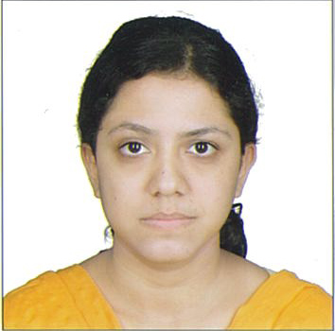
Anwesha
Anwesha.358258.@2freemail.com
UAE
Education
DEGREE/UNIVERSITY | YEAR | SUBJECT | PERCENTAGE
B.Sc | 2011 | Mathematics | 52%
Intermediate | 2008 | Science | 78%
High School | 2006 | Science, Language | 75%

CARRER OBJECTIVES:
Skilled Elementary Teacher With A Background In Improving Students Performance. Focused On Working With Students, Parents, Colleagues, And Administrators Alike To Teach And Motivate Students.
Looking For a Challenging And Responsible Opportunity, Explore Strengths And Potentials in a Professional Organization To Meet Employers Expectation.

Work Experience:
3 year teaching experience as Middle School Teacher.
Computer Knowledge:
MS-Office, Windows-XP, MS-Word, MS-Excel, Visual FoxPro, Internet And Email
PERSONAL QUALITIES:
Highly Motivated And Eager To Learn New Things
Ability to produce best result in pressure situation.
Ability to work as individual as well as in group.
Good communication skills in English written and verbal both.

