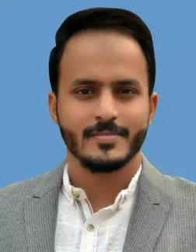
Muhammad
Muhammad.358360@2freemail.com

PERSONAL INFORMATION
D.O.B: | 09-10-1992
Nationality: | Pakistani
OBJECTIVE

Looking forward to work and enhance my skills in an esteemed progressive organization having a culture of committed excellence, teamwork and acme of opportunities for an individual professional growth.

ACADEMIC EDUCATION

Bachelor of Computer Science |  | 2012 | - 2016
 | Govt. College University, Faisalabad
 | Intermediate (Pre-Engineering) | 2009 | – 2011
 | (Board of Intermediate and Secondary Education)
 | Matriculation (SSC) | 2007 | - 2009
 | (Board of Intermediate and Secondary Education)

TECHNICAL SKILLS

Web Programming

HTML, CSS, HTML5/CSS3, Twitter Bootstrap, JavaScript, jQuery, Ajax, PHP, MySQL, Codeigniter, WordPress, eBay store listing template

Graphic Designing / Web Designing

Logo, Banner, Poster, Business Card, Brochure etc.
Software

Adobe Dreamweaver, Adobe Photoshop, Adobe illustrator

LANGUAGES PROFICIENCY

Communication Verbal & Written (English, Urdu, Hindi & Punjabi).

EXPERIENCE

 | Full Stack Developer at SmartanSolver | 2015-2016
 | I worked in Smartansolver for more than 1.5 year and have worked on variety of projects
 | which increases my experience in different tool and technologies.
 | Web Developer | Dec/2016 – Feb/2017

I worked in Digitalsofts 3 month on Php Codeigniter (MVC Framework) projects and learned many things.

EXTRA CO-CURRICULAR ACTIVITIES

Drawing, Art, Video Games

