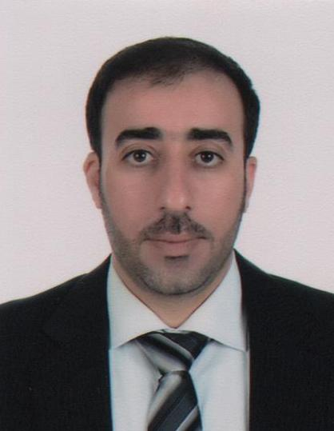
C V
Tarek
Tarek.358380@2freemail.com

Teacher of Arabic ( Approved by KHDA)
Education
Qualifications | - Faculty of Arts  - University of Damascus.  - B.A degree in Arabic Language & Literature. 2002  - A Diploma in Education. 2004
Languages | Language Skill degree  Arabic Native.  English Very good reading, writing & Good speaking.
Professional experience
Profile | - Advanced educational modelling skills.  - In-depth knowledge of students' requirements and staff sector co-operation.  - Effective planning and organizational skills.  - Ability to work well both independently and in a team environment.  - Ability to successfully manage multiple priorities and assignments.  - The ability to teach through computer.  - Advanced standard of computer skills.  - The ability to improve the handwriting of any student.  - Dealing with Different levels and standards of students' abilities.
Career & Assignment History | - Worked as a teacher of Arabic for " Al Sarh Islamic School - KSA "  S september 6, 2003 – March 31, 2004.  - 2004 – Present, working as a teacher of Arabic for Dubai National School - Dubai – UAE.  - 2004 UNTIL 2009 : Teaching Arabic language for non-Arabic Speakers  - 2010 UNTIL NOW : Teaching Arabic language for Arab students (Grades 7-8-9-10-11)  - I have the ability to work with teachers as a team for the benefit of our students in order to develop learning skills ,discover the areas of weakness, and take action accordingly.  - I was in charge of Grades 7,8,9,10,11 teachers in terms of preparing lesson plans, handouts, worksheets, quizzes, final exams, PowerPoint Presentations, etc. “Dubai National School” 2009- 2016  - I have wide and extensive experience of IB system (PYP), (MYP), and (DP). This system focuses on developing research and critical thinking skills as well as asking questions that make the students live in a challenging environment, which ultimately helps to achieve targeted goals.
Development courses (Certificates ) | - 2005: Teaching Arabic Books (1, 2, 3, 4, & 5) for non-Arabic-Speaking students at Educators’ Centre.  - 2005 : Teaching Arabic As a Second Language at Educators’ Centre.  - 2006 : Using Technology-based teaching techniques at Dubai National School.  - 2006 : Classroom Management at Dubai National School.  - English Language Course (Level 6 , 7)BRITISH CONCIL  - Using Technology to Improve Student Learning In the Content Area. The College of Learning, Zayed University.  - Standards-based Instructions. The College of Learning, Zayed University.  - Creating a Positive Classroom Learning Environment. The College of Learning, Zayed University.
Personal skills | - Ambitious.  - Self-motivated.  - Self-confident.  - Hard worker.
Personal Strengths
- I participated with my students in several educational contests, including Poetry Recitation, Drama, Elocution, Debates, etc. My students have achieved remarkable results in these competitions.
- I use technology in my educational practice all the time through the use of PowerPoint Presentations, Internet, Edmodo, and Social Networking.
- I use learner-centred classrooms that allow students to take the lead and become responsible for their own learning.
Computer Skills : ICDL (2007)
Using Smart Board

