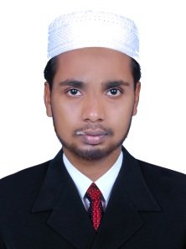
CURRICULUM VITAE

RAZAQUE
Email: razaque.358425@2freemail.com
Mob: C/o 0505891826

OBJECTIVE
To learn and function effectively in an organization and be able to deliver to the bottom-line to constantly upgrade my knowledge and skill and make a difference in whatever I do
ACADEMIC DETAILES
- MA Public Administration (CDOL) pursuing at Central University of Jamia Millia Islamia
- BA English Language and Literature with Journalism (2015) with aggregate of 60% from University of Calicut
- HSE (2012) with the aggregate of 65% from Board of Higher Secondary Examination Govt. Kerala
- SSLC (2010) with aggregate of 63% from Board of Secondary Leaving Certificate Examination Govt. Kerala
PERSONAL INFORMATION
Date of Birth : 30/07/1994
Gender : Male
Nationality : Indian
Marital Status : Single
Languages Known : English, & Malayalam
DECLARATION
I do hereby declare that the particulars of information and facts stated herein above are true, correct and complete to the best of my knowledge and belief.
RAZAQUE

Date :

