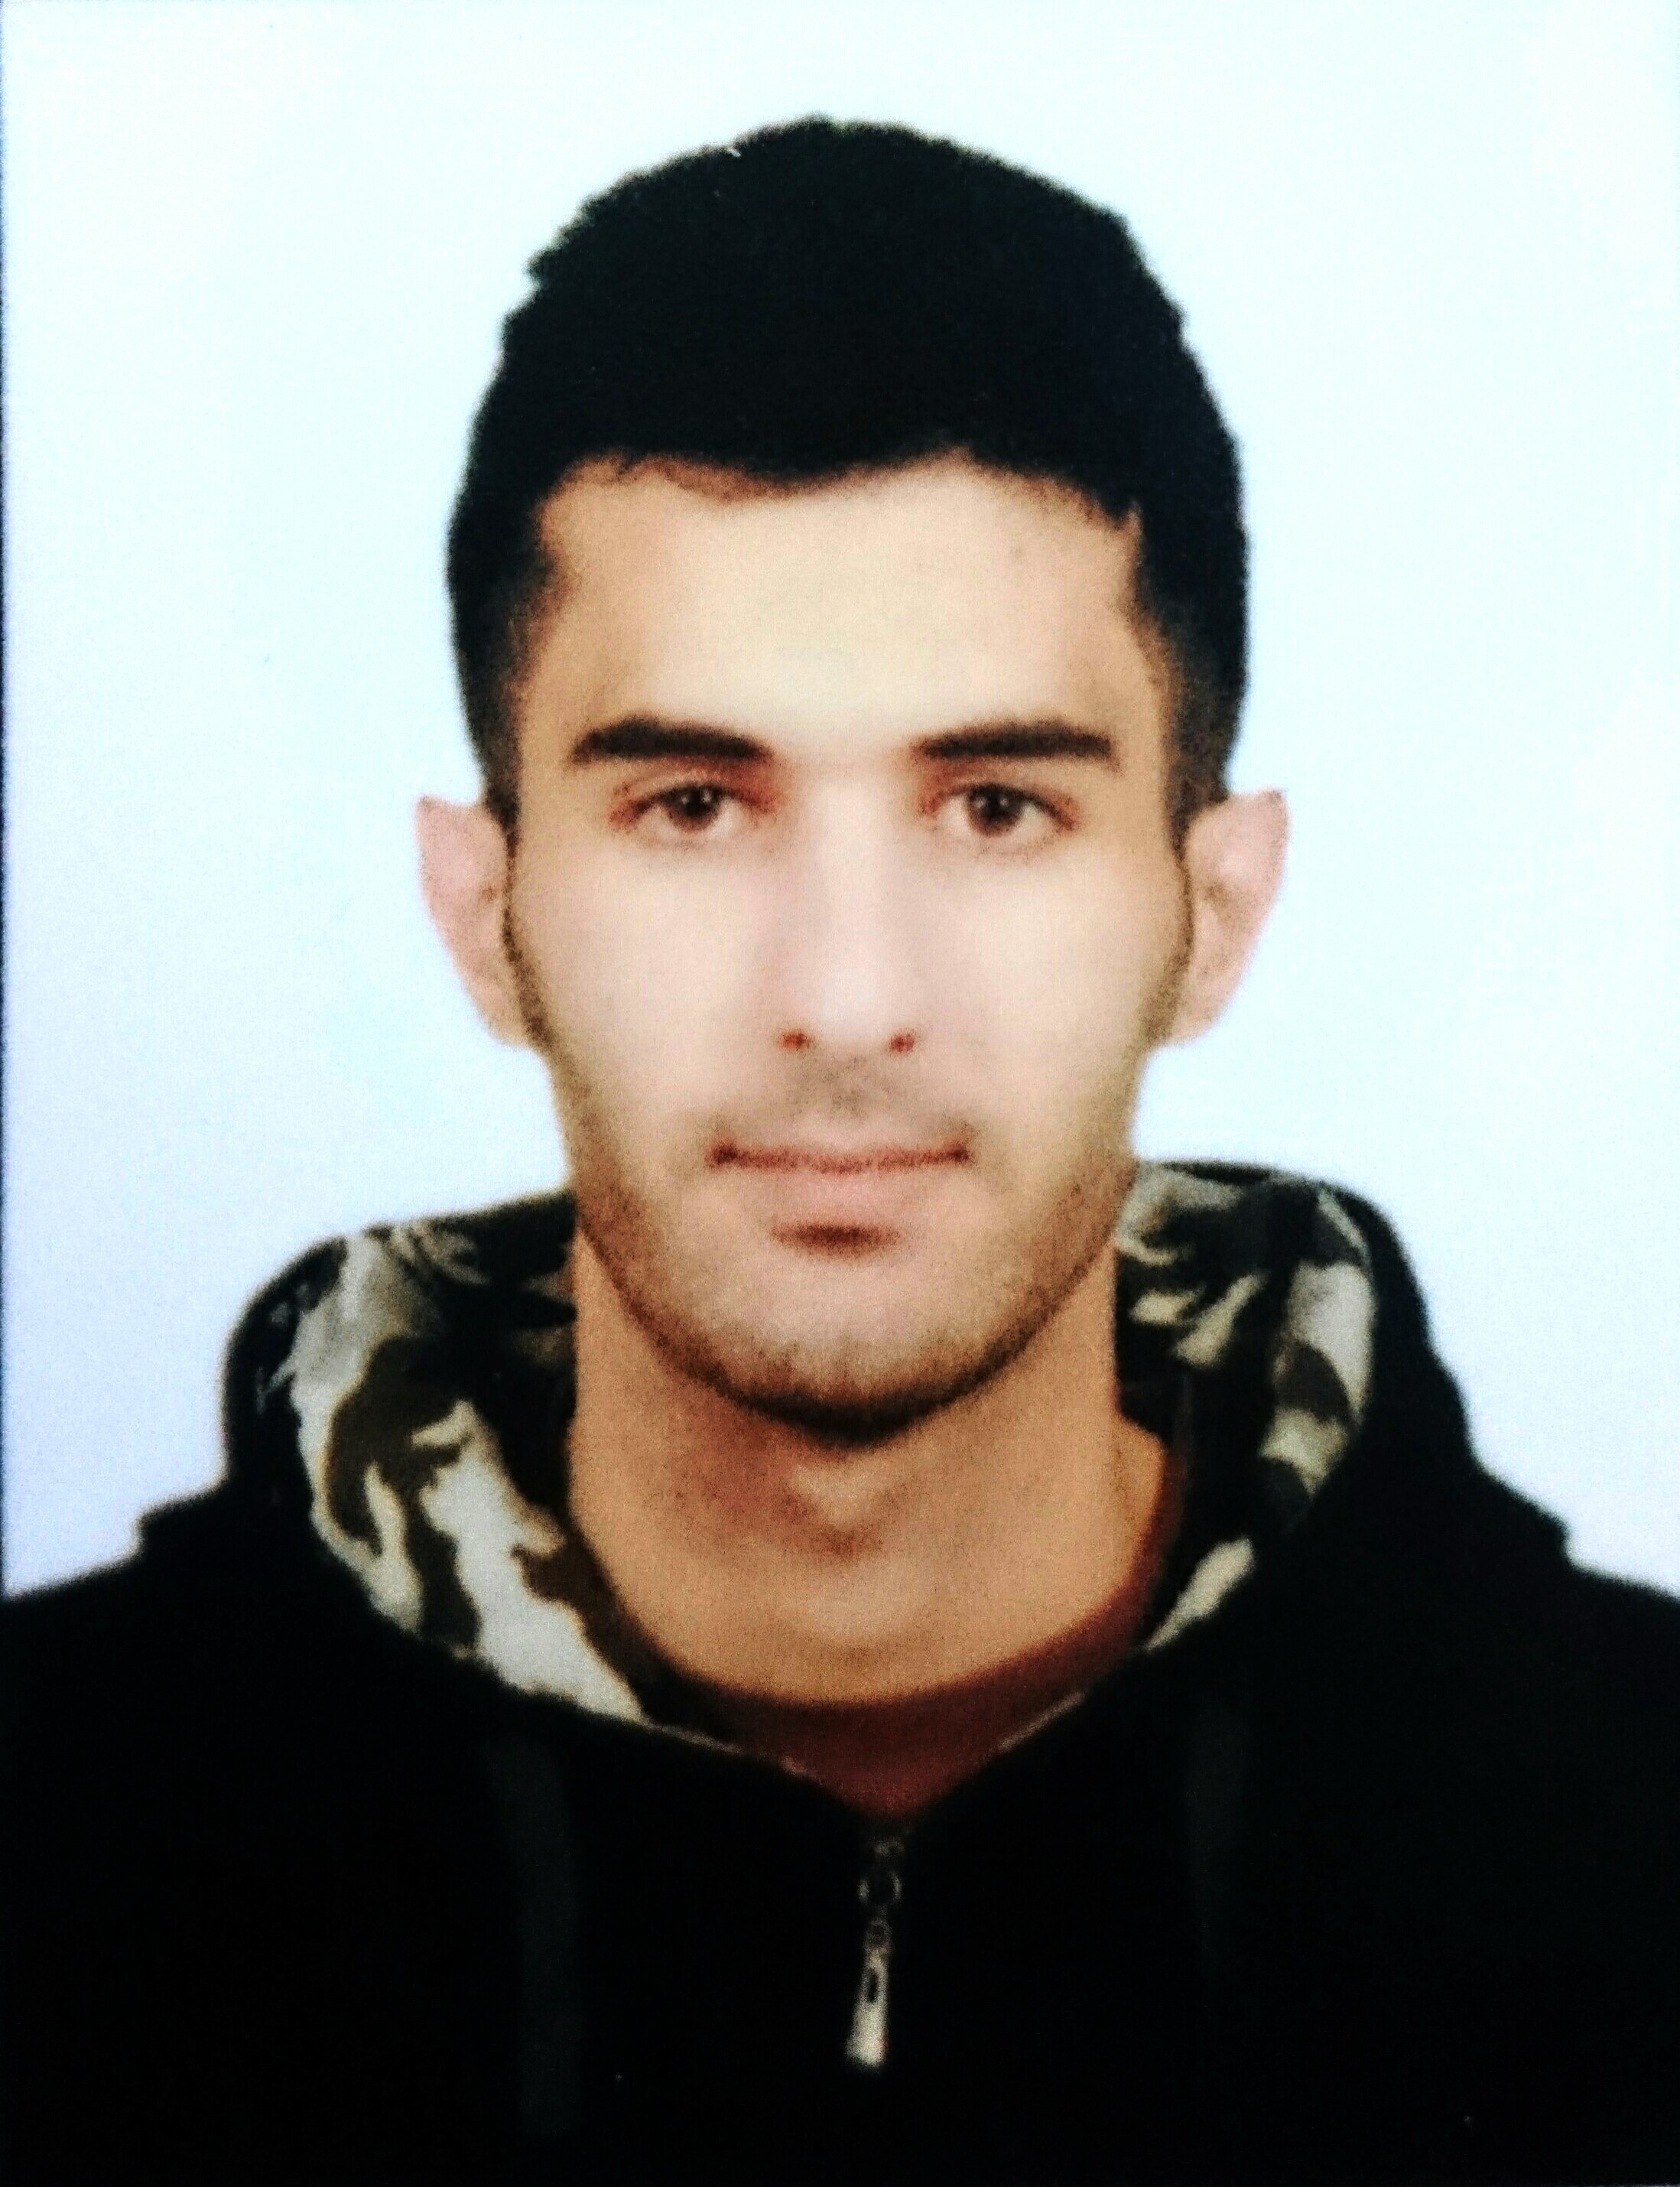
CV

Personal Data :
Name : Feras
Date Of Birth : 1993/10/3
Place Of Birth : UAE
Nationality : Palestinian
Social Status : Single
Age : 23
Email : feras.358533@2freemail.com

Qualifications :
Bachelor of Banking and Financial Science 2016
In Alquds Open University

Scientific Sessions :
Advanced Microsoft Office Excel Course (30Hours)
Advanced Microsoft Office Access Course (30Hours)
Computer maintenance Course (40Hours)
ICDL Course (40Hours)

Personal Skills :
Teamwork, Time management, Fast learning
Communication & Public Relationship
Languages | Reading | Writing | Conversation
Arabic | Excellent | Excellent | Excellent
English | Excellent | Very good | Very good

