CURRICULUM VITAE
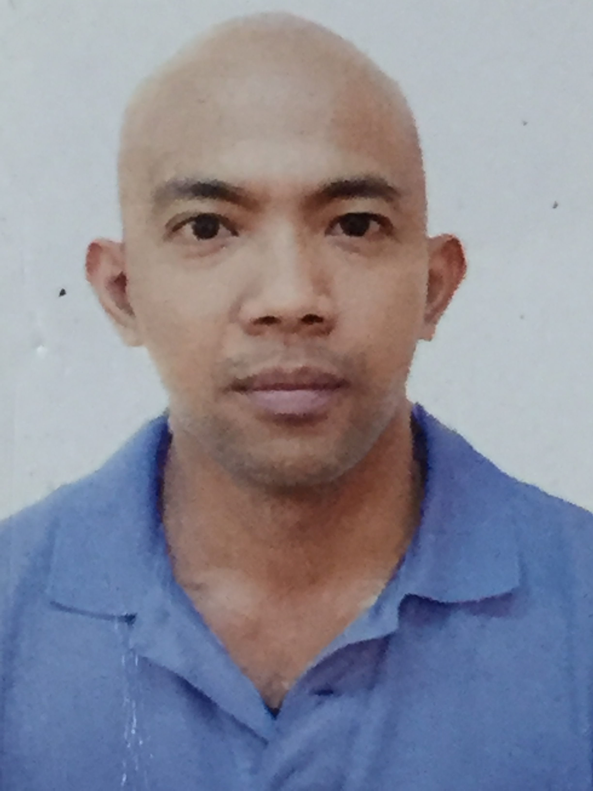
Jonah
Cell Phone No# C/o 0506425478
Email Address jonah.358563@2freemail.com

Career Objective:

Seeking a position as safety officer where I can utilizes my skills and achievement for implementing health and safety at work.

Summary Skills:
- Experienced on actual emergencies and implement proper procedures.
- Strong working experience in emergency control room operator in emergency services.
- Knowledge in National Fire Incident reporting system software
- Basic knowledge in computer software
- Remarkable ability to work calmly and accurately under intense pressure, Quick thinker and flexible
- Ability to work independently emergency situation.

PROFESIONAL EXPERIENCE:
Present Employment:
Position: Emergency Control Room Operator
Duration: June 10, 2014 to Present
Company: Fujairah International Airport Department of Civil Aviation
Department: Rescue Fire fighting Services
Location: Fujairah International Airport U.A.E
Emergency Control Room Operator
- Control Room Operator reports directly to the duty Watch Commander, ensuring all fire and rescue communication channel are established and full operation during all emergency situations.
- Maintaining the accurate passage of information and to other agencies.
- Organize manpower allocated in case of emergency response.
- Prepare for approval of the fire chief all communications plans, procedure techniques and operating instructions.
    - Provide assistance and information to all persons involved in abating an emergency protecting lives and properties.
    - Monitor and record fire Vehicle movements and notify concerned agencies as appropriate.
    - Providing coordination services with outside agencies ensuring smooth and efficient operation.
- Maintain a log of all emergency messages including exercise.
- Mans and operates the Fire Control Center is responsible for all aircraft incidents such as ground Incident, Fuel Spill, Road Traffic Accident, Refuelling Standby, Defueling Standby, Ambulance Call, Emergency Fuel Shutdown, Structural Fire, VIP Standby and Fire Alarm activation.
- Undertake daily cleaning on the control room.

Previous Employment:

Position: Emergency Control Room Operator

Duration: May 13, 2012 to June 15, 2013

Company: Saudi Sicli Company, P.O Box NO. 16016 Jeddah K.S.A

Department: Department of Emergency Fire Rescue Services

Location: Prince Mohammed Bin Abdullaziz International Airport

Madina K.S.A

Previous Employment:
Position: Emergency Control Room Operator
Duration: July 18, 2009 to August 28, 2011
Company: Afras Trading and Contracting Co., P.O Box 6337 Riyadh K.S.A
Department: Department of Emergency Fire Rescue Services
Location: King Khaled International Airport
Riyadh, K.S.A
Previous Employment:
Position: Electronics Technician
Duration: March 2005 to December 2007
Company: Self Employed
Location: #35 Urbiztondo San Juan, La Union Philippines

TRAINING AND COURSE ATTENDED:
- NEBOSH Training on IGC1,IGC2 and IGC3
- Aviation English & RT Training Level 4 operational
- Introduction to Incident Command system ICS-100
- ICS for Single Resources and Initial action Incident ICS-200
- Fire safety training on First Aid Emergency Skills
- Fire Safety Training on application on fire extinguisher
- Fire safety training on Dangerous Goods Familiarization
- Introduction to Occupational Safety and Health
- Introduction to Safety Management
- Emergency Response Planning
- Radiation Safety Awareness
- Incipient Fire Fighting Awareness Level 1
- Unified Command-Awareness Level 1
- Hazardous Material Response-Awareness Level 1
- Emergency Operation Center Awareness
- Incident Command System-Awareness Level 1

EDUCATIONAL ATTAINMENT:
Educational level: College Graduate
Major / Field: Electronics Technology
Course: Bachelor of Science in Industrial Technology
University: Don Mariano Marcos Memorial State University
Location: San Fernando City, La Union, Philippines
Year: 1999 – 2003
Secondary:
School: La Union National High School
Location: Catbangen San Fernando City, La union, Philippines
Year: 1995 – 1999

Elementary:
School: Nadsaag Elementary School
Location: Nadsaag, San Juan, La Union, Philippines
Year: 1989- 1995
Personal Information:
Date of Birth: December 15, 1981
Nationality: Filipino
Civil Status: Single
Height: 5’2
Weight: 145lbs
Religion: Christian

