CV of a Senior Graphic Designer

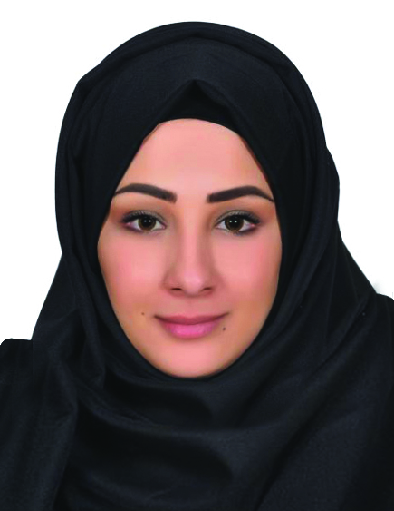
Profile
Name: Sara
Nationality: Lebanese
Date of Birth: Jan.18.1986
Work Experience: U.A.E experience for more than 9 years.

About Me
I am Senior Graphic Designer, I can do Graphic design |Digital Design|| Layout | Creative/Art Direction | Social Media Design | Concept Design.
I have a various experience in Graphic designing field for both publishing and commercial work, Like Newspapers, Magazines, Books, Tabloids, advertising work, campaigns, stationaries, in both Arabic and English as well, can present the work as a presentation or as a dummy or a print out, I am also capable to search for photos that serve the designs and edit them.
I am Motivated, committed and a hardworking person. And I use my skills in the best possible way for achieving the company’s goals”

Soft wares Knowledge
I work on the following Software:
Photoshop | Illustrator | InDesign | Adobe Acrobat| Quark express.
Microsoft Office
I am a Mac system user/ Windows also if needed.

Work Experience

Brands Group Company– Abu Dhabi (2014-2015)
Senior Graphic Designer
Task: Creating anything related to Design, indoor, out Door, Stationaries, Books, Magazine plus following up with Clients and the work team, organize all design related work.

Express Printings- Abu Dhabi (2013-2014)
Art Director/ Senior Graphic Designer
Responsible of creating anything related to design in the Press design department, handling a bimonthly magazine, and I follow up with the management and two other graphic designers to achieve the best for the work.

Integrated Media Solutions – Dubai (Al Roaya Newspaper) (2008-2013)
Senior Graphic Designer
Senior Graphic Designer doing multiple work kinds like Page Lay outing, Advertising design, and info graphic if needed plus making presentations for new layouts Concept under the administration of a Creative Art Director.
Arab Media Group-Emirate Layout Tabloid –Dubai (2005-2008)
Graphic Designer
Responsible of creating page Layout and design Mainly for life style work in addition to photo cutouts and editing.

Al Watan newspaper-Abu Dhabi (2003-2005)
Executive Graphic Designer
Responsible of creating page Layout and design. Also Created Magazine Template plus Handling Weekly creative life style Tabloid issued by the company.

(Note: Experience Letters available for all above mentioned jobs).

EDUCATION
Professional Diploma in interior design
CEE institution- Dubai.

OTHER CERTIFICATES
Graphic design intensive course.
Emirates College of Technology and Science-Abu Dhabi.

SKILLS
Photography
Photo Research
Social Media

LANGUAGES
Arabic (Native)
English (Expert Reading, Writing and Listening)

Communication
E-mail: sara.358571@2freemail.com
Mobile: C/o 0502360357

